**Sound for Interactive Media Project Journal**

**Week 1**

This week was an introduction to the module we looked at ideas of non-linearity, interactivity, and generativity in media.

I already have an idea of what I want to create for my final project, an interactive and generative piece of sound art potentially also incorporating visual elements. My initial idea is that users will be able to record a short amount of sound through their computers microphone. The system will then use this as the base material to create a generative piece. I think using ideas from Nick Collins’ book Microsounds would be very interesting in a generative sense. I could split up the user’s recording into extremely small ‘grains’ and organise and manipulate these from a micro to macro level. I also think use of data feedback would be a great way to add complexity at this conceptual stage. The system logic could be consistently ‘looking’ back at what has been output in the past few seconds to form future compositional decisions, in this way a very unique composition is possible as output becomes very far removed from the input.

Regarding discussion in class, the idea of implementing this in an app would also be potentially interesting as users would have the ability to record a much wider range of starting audio material e.g., such as birds chirping, due to the portability of phones. Initially I am going to start this project using p5.js but if it turns out not to be well suited, I have the option to change.

One element which was discussed in the seminar was privacy issues. Google chrome and other modern browsers have specific requirements that data be stored securely, and this can cause issues with audio-based websites. I just need to make sure that my system complies with any specific regulations so that it’s super available to users.

Another idea I had was to utilise complex graphics functions from the natural world such as daily rainfall data or movement in herds of buffalo or ant colonies. I could use this data to introduce complexity in my system for example relating it to probabilities of events occurring and Markov chains, elements discussed in this week’s seminar. I also could relate these to synthesis parameters and use complex mapping structures such as many to many and use of reciprocals. I will need to do extensive testing and evaluation in my project to create a system which consistently creates interesting outputs.

The reading for the week related to video game audio(quote reading name). I thought that the reflection on the listening and play environment of video games and how this has changed over time was interesting. Noting the change from noisy arcades to home environments where the video games don’t need to compete with each other sonically to grab attention of potential players. This change in play environment allows video games to have a much larger dynamic ranges in their soundscapes as more subtle sounds can still be heard. Whilst the medium of video game doesn’t link with my project, I think there is evident benefit in considerations relating to listening environment and how this can impact sonic design choice.

In the weekly task, I created a p5.js patch showing at a basic level use of sound and image creation and use of interactivity to manipulate this. My patch consisted of some concentric circles and a sine wave generator. The position of the mouse, via mouseX and mouseY variables? changed the colour of different circles and the pitch of the sine wave generator. I made this interesting in my use of equations and mappings so that there was some variability in the way the shapes changed colour. Patch below:

var wave;

function setup() {

createCanvas(windowWidth, windowHeight);

wave = new p5.Oscillator();

wave.setType('sine');

wave.start();

wave.freq(440);

}

function draw() {

background(220);

fill(255*(1-((mouseX*mouseY)/(windowWidth*windowHeight))));

ellipse(windowWidth/2, windowHeight/2, windowWidth, windowHeight);

fill(0,0,255*(mouseX/windowWidth))

ellipse(windowWidth/2, windowHeight/2, 3*windowWidth/4, 3*windowHeight/4);

fill(0,255*(mouseY/windowWidth),0)

ellipse(windowWidth/2, windowHeight/2, 2*windowWidth/4, 2*windowHeight/4);

fill(255,0,0)

ellipse(windowWidth/2, windowHeight/2, windowWidth/4, windowHeight/4);

wave.freq(mouseY);

// print(1-((mouseX*mouseY)/(windowWidth*windowHeight)))

}

Help from: https://editor.p5js.org/shiffman/sketches/BJpSZ9Cyg

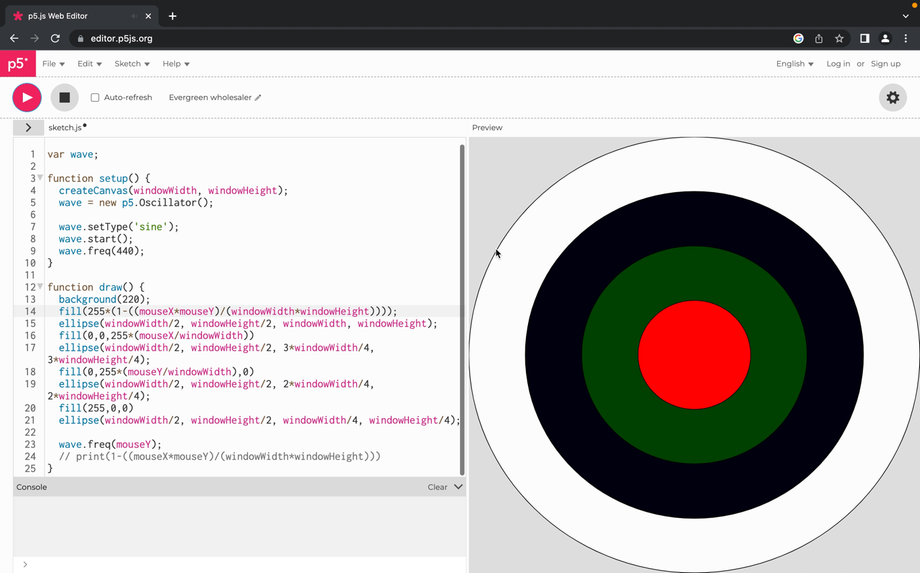

Video File name: Journal 1.1

**Week 2**

I reviewed the basic module information to make sure that I kept within the scope of the module with my research. I researched a game of life (<https://www.youtube.com/watch?v=ouipbDkwHWA>), a generative game based around simple rules which creates patterns emulating stuff found in the natural world. I think that this could be utilised really interestingly in a generative piece. For instance, each square could represent a potential tone which is generated if the square is ‘alive’. I found an example in p5.js, looked through the code line by line printing variables to the console log to understand it, and added in an element of synthesis my addition is in **red and bold.**

let w;

let columns;

let rows;

let board;

let next;

**var wave;**

function setup() {

// Set simulation framerate to 10 to avoid flickering

frameRate(10);

createCanvas(720, 400);

w = 20;

// Calculate columns and rows

columns = floor(width / w);

rows = floor(height / w);

// Wacky way to make a 2D array is JS

board = new Array(columns);

for (let i = 0; i < columns; i++) {

board[i] = new Array(rows);

}

// Going to use multiple 2D arrays and swap them

next = new Array(columns);

for (i = 0; i < columns; i++) {

next[i] = new Array(rows);

}

init();

**wave = new p5.Oscillator();**

**wave.setType('sine');**

**wave.start();**

}

function draw() {

background(255);

generate();

for ( let i = 0; i < columns;i++) {

for ( let j = 0; j < rows;j++) {

if ((board[i][j] == 1)) fill(0);

else fill(255);

stroke(0);

rect(i * w, j * w, w-1, w-1);

}

}

}

// reset board when mouse is pressed

function mousePressed() {

init();

}

// // Fill board randomly

function init() {

for (let i = 0; i < columns; i++) {

for (let j = 0; j < rows; j++) {

// Lining the edges with 0s

if (i == 0 || j == 0 || i == columns-1 || j == rows-1) board[i][j] = 0;

// Filling the rest randomly

else board[i][j] = floor(random(2));

next[i][j] = 0;

}

}

}

// The process of creating the new generation

function generate() {

// Loop through every spot in our 2D array and check spots neighbors

for (let x = 1; x < columns - 1; x++) {

for (let y = 1; y < rows - 1; y++) {

**print('x=', x)**

**print('y=', y)**

// Add up all the states in a 3x3 surrounding grid

let neighbors = 0;

for (let i = -1; i <= 1; i++) {

for (let j = -1; j <= 1; j++) {

neighbors += board[x+i][y+j];

}

}

// A little trick to subtract the current cell's state since

// we added it in the above loop

neighbors -= board[x][y];

// Rules of Life

if ((board[x][y] == 1) && (neighbors < 2)) next[x][y] = 0; // Loneliness

else if ((board[x][y] == 1) && (neighbors > 3)) next[x][y] = 0; // Overpopulation

else if ((board[x][y] == 0) && (neighbors == 3)) next[x][y] = 1; // Reproduction

else next[x][y] = board[x][y]; // Stasis

**if (board[x][y] == 1){**

**print('board', board[x][y])**

**wave.freq(x*y);**

**}**

}

}

// Swap!

let temp = board;

board = next;

next = temp;

}

The main part of my addition is an if statement positioned within a for loop which is encapsulated within another for loop. These two for loops act to apply the rules of the game of life iteratively to every cell. The positioning of my if statement within this allowed me to iteratively determine if each cell was alive if the array ‘board’ = 1 for a given x or y coordinate (cell). If a given cell is alive a sine wave is generated at the frequency of its x and y positions multiplied. As for loops iterate almost instantaneously the sine wave tones 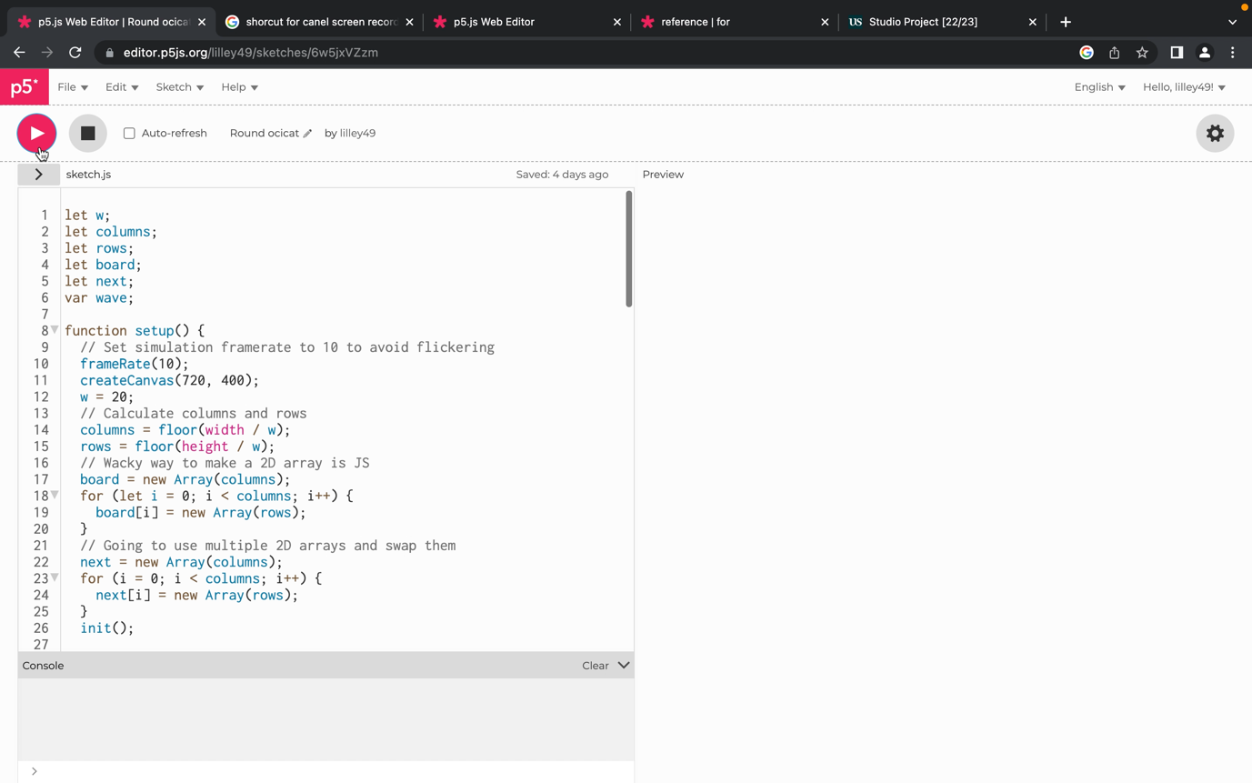combine for a given set of positions on the board. Below is a video of the code working.

Video file name: SFIM Game of life.mov

This was very interesting however I wanted to add a slight delay between each tone to create more of a sense of an evolution of sound rather than a combination of tones. I researching into all related delay objects in the p5.js references and <https://stackoverflow.com/questions/3583724/how-do-i-add-a-delay-in-a-javascript-loop> (Accessed 5 February 2023). I identified ‘setTimeout’ as a function I might be able to use. However, I received no results upon searching for it in the p5.js references. I tried calling it in a patch, but it wasn’t recognised. I sat down and reviewed the ‘stackoverflow’ post again and realised ‘setTimeout’ function has specific requirements, the delay value place at the end of the function within the outer brackets.

I experimented with the placement of the delay and decided on placing the delay within the if statement. So, if the cell is alive delay by 1/10th of a second and play sine wave.

<https://editor.p5js.org/lilley49/sketches/6w5jxVZzm>

I found that this was more interesting as when the cells were changing there are brief moments of more sonic complexity as the delay makes changes(and the cycling) between sounds audible. However, through this I realised that the reason I am not getting the complex symphony of sine waves as I anticipated was that only one sine wave was playing at a time (I had only created one synthesiser object). The only reason I realised this was through adding the delay and hearing the synthesiser quickly change between frequencies. Ideally, I wanted the functionality in my code for each cell to control a sine wave however I decided to take a methodical approach adding in one more sine wave generator. I added in all the required initialisation in the set-up and then a conditional within the ‘setTimeout’ function that if y is even ‘wave’ variable is triggered and if y is odd ‘wave2’ variable is triggered. I worked out odd and even conditions using <https://www.programiz.com/javascript/examples/even-odd> (Accessed 10 February 2023).

<https://editor.p5js.org/lilley49/sketches/6w5jxVZzm>

if (board[x][y] == 1){

setTimeout(function () {

if (y % 2 == 0){

print('board', board[x][y])

wave.freq(x*y);

}

else{

wave2.freq(x*y);

}

}, 100);

}

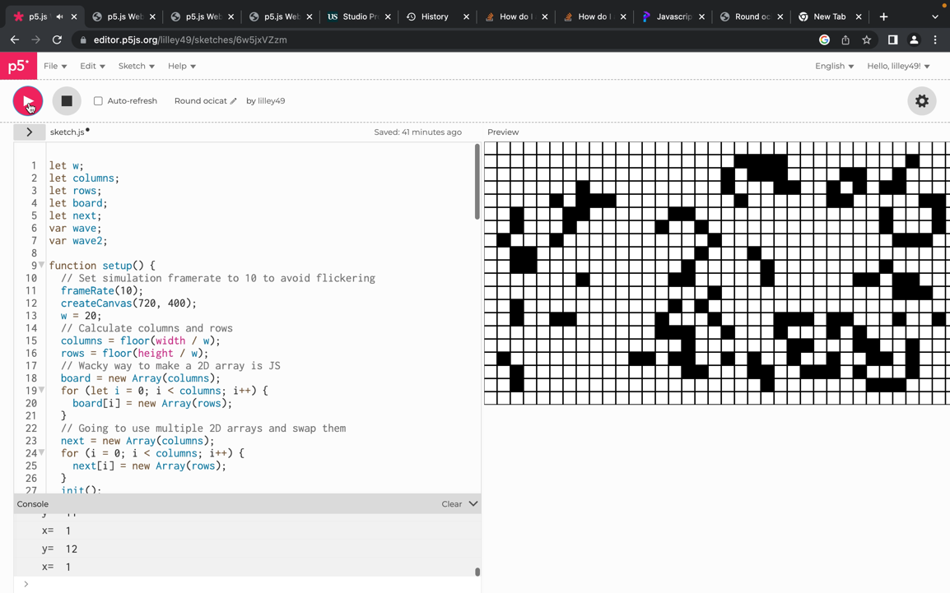

Video file name: Journal 1.2.mov

The reading for this week was on Gibber and live coding in the browser. I was reminded of the applications of Gibber for use in JavaScript, this is something I might experiment with in my project. I think that Gibber software is potentially worth looking at for my project due to its integrated library of audio functions and its synergy with Javascript. I had previously thought it was simply for live coding, but it can also be used outside of this context and has creative synthesis options. Also in the reading, there is some discussion between the benefits of different browsers, I want to keep my project as accessible as possible so I will need to look into this (Roberts and Maron note Apples security restrictions as potentially problematic). However, the reading was published in 2012 so the technology may have changed. Furthermore, in the project I will want to explain why I have used specific programming languages noting among other things issues such as usability, efficiency, security. The reading also inspired me in terms of creating creative mappings for varied and interesting user experience.

Notes on Lecture:

Thought plink was really cool – go back to week 2 – especially prototyping bbc – because it explains code in great way ‘Preamble We use jQuery, backbone.js and some custom UI elements (namely a [knob](https://webaudio.prototyping.bbc.co.uk/docs/knob.html) a [speech bubble](https://webaudio.prototyping.bbc.co.uk/docs/speechbubble.html) and a [switch](https://webaudio.prototyping.bbc.co.uk/docs/switch.html)) in this application. We make these libraries available to our application using [require.js](http://requirejs.org/)’ – I think something like this could be good – it needs good amount of user control – increase sound particles – slider – increase energy etc. more collisions.

**Week 3**

I read some of Microsound (2004) by Nick Collins. I thought it might be interesting to attempt to implement some of the ideas presented in the book into my project. The idea of approaching sound as particles is really intriguing and I understand it, but I tried explaining the concept to my non-musical friend and they found it hard to make sense of. There could be a bit of a niche here exploring these ideas.

**Week 4**

I worked out how to create multiple variables quickly. This was important because I knew for my project I would be using multiple different synthesisers or sound file instances and I didn’t want to create unnecessary lines of code initialising potentially hundreds of variables. I attempted to use the code below I knew the logic I wanted to use but clearly I was not using the syntax correctly.

var wave;

function setup() {

createCanvas(400, 400);

for (let i = 0; i < 9; i++) {

var wave(i) = new p5.Oscillator();

console.log(i);

}

}

I wanted to use a for loop to efficiently create new oscillators (in this example) for different instances of a variable. Upon reviewing the code and thinking logically I realised I needed an array for this function. The code below worked.

var arr = [];

function setup() {

createCanvas(windowWidth, windowHeight);

for (let i = 0; i < 15; i++){

arr[i] = new p5.Oscillator();

arr[i].setType('saw');

arr[i].start();

}

}

For the first 15 elements of array ‘arr’ a new oscillator is created using the for loop. This is efficient compared to listing the 15 individually and also allows me to change the number from 15 to x extremely efficiently.

I wrote the below patch to demo the idea I had implemented.

var arr = [];

var x;

var y;

function setup() {

createCanvas(windowWidth, windowHeight);

for (let i = 0; i < 15; i++){

arr[i] = new p5.Oscillator();

arr[i].setType('saw');

arr[i].start();

}

}

function draw() {

background(0);

for (let i = 0; i < 15; i++){

let x = random(windowWidth);

let y = random(windowHeight);

arr[i].freq(x*y);

circle(x, y, 20);

}

}

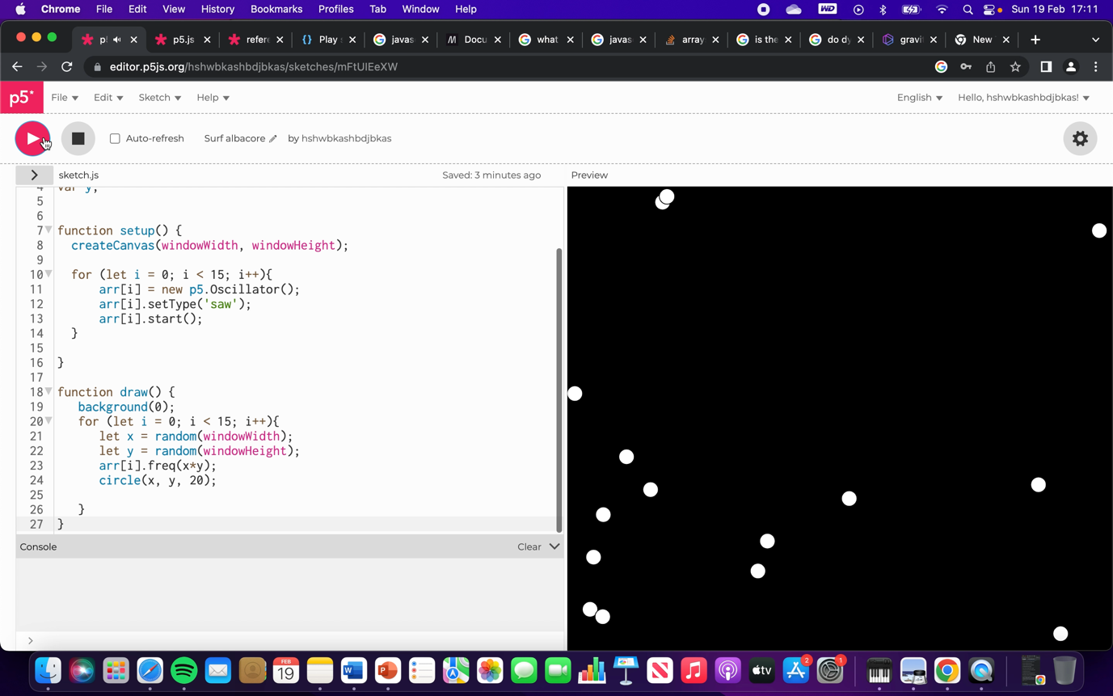

Video file name: SFIM Journal Video 1.2.mov

As previously explained in the setup I use a for loop to create oscillators for the first 15 elements in the ‘arr’ array. In draw which loops at the frame rate I then use another for loop to generate random values for variables ‘x’ and ‘y’ which determine the frequency of a given oscillator for its associated index value. For example, if i=4, and numbers ‘100’ and ‘4’ were generated for ‘x’ and ‘y’ oscillator 5 (arr[4]) would output at frequency of 400. A circle also represents these random numbers and oscillator frequency as it is positioned at x,y coordinates. This happens for all 15 elements of ‘arr’ array and repeats as the draw function loops at the frame rate.

**Week 5**

I did research into the different simulation examples on the p5.js website. I thought many of these were really interesting and were a good base to create complex musical systems using programming. I thought about different ways which I could sonify some of these examples for example ‘Flocking’ and ‘Snowflakes’. A lot of these examples contain a mass of individual bodies which move through some logic. I though given the variety of individual bodies etc. they could be sonified in interesting ways.

I wanted to create a gravity effect… I looked at flocking.

**Week 6**

I took the p5.js ‘Forces’ (<https://p5js.org/examples/simulate-forces.html> (Accessed: 28 February 2023)) example and experimented with stripping out elements. I created adapted the force of ‘gravity’ in the example to change depending on a particles position around the centre of the game space. I also created a variable ‘coefficient’ which stores a value relating to the relationship between the distance of a particle to x and y coordinates of the particle. This variable is applied to particles this.velocity to help create a natural looking ‘orbiting’ movement profile. To create an ‘orbiting’ movement profile the relationship between the x and y components of velocity as a particles moves through the orbit.

I adapted the example to create this code:

let particles = [];

let directionx = 0;

let directiony = 1;

var calx;

var caly;

let coefficient = 0;

function setup() {

createCanvas(windowWidth, windowHeight);

reset();

}

function draw() {

background(220);

background(0);

fill(255,255,0);

circle(windowWidth/2, windowHeight/2, 60)

for (let i = 0; i < particles.length; i++) {

if (particles[i].position.x < windowWidth/2){

directionx = 1;

}

else{

directionx = -1;

}

if (particles[i].position.y < windowHeight/2){

directiony = 1;

}

else{

directiony = -1;

}

let gravity = createVector(directionx/5, directiony/5);

particles[i].applyForce(gravity);

particles[i].update(5000);

particles[i].display(5000);

calx = particles[i].position.x - windowWidth/2

caly = particles[i].position.y - windowHeight/2

// if (coefficient == 0) {

coefficient = calx/caly;

// }

console.log(coefficient);

// particles[0].checkCollision(particles[1]);

}

setTimeout(40);

setTimeout(function () {

}, 100);

}

function reset() {

for (let i = 0; i < 10; i++) {

particles[i] = new Mover(3, (random(windowWidth)) , random(windowHeight));

}

}

function Mover(m, x, y) {

this.mass = m;

this.position = createVector(x, y);

// for (let i = 0; i < particles.length; i++) {

// }

this.velocity = createVector(1*coefficient, 1);

this.acceleration = createVector(0, 0);

}

let hello = function(x, y, w, h, c) {

this.x = x;

this.y = y;

this.w = w;

this.h = h;

this.c = c;

};

hello.prototype.display = function() {

noStroke();

fill(50);

rect(this.x, this.y, this.w, this.h);

};

Mover.prototype.update = function() {

this.velocity.add(this.acceleration);

this.position.add(this.velocity);

this.acceleration.mult(0);

};

Mover.prototype.display = function() {

stroke(0);

strokeWeight(2);

fill(255);

ellipse(this.position.x, this.position.y, 16, 16);

};

Mover.prototype.applyForce = function(force) {

let f = p5.Vector.div(force, this.mass);

this.acceleration.add(f);

};

// checkCollision(other) {

// // Get distances between the balls components

// let distanceVect = p5.Vector.sub(other.position, this.position);

// // Calculate magnitude of the vector separating the balls

// let distanceVectMag = distanceVect.mag();

// // Minimum distance before they are touching

// let minDistance = this.r + other.r;

// if (distanceVectMag <= minDistance) {

// console.log('hello');

// }

// }

Trying to add in detect collisions – using the example one – but I am using an array for particles not object – so changing over ‘particles’ to object – that is what I am trying – or a class even

Code: <https://editor.p5js.org/lilley49/sketches/bL7Ala0mr> - Not working

They were matching with themselves (the particles are triggering collisions with themselves – this is a problem)

Problem was that – I think – they will never be exactly the same – so + - radius – was looking at – if the x positions are equal – they will never be equal because it its ……. Decimal point number – so added in bounds.

Next - put sample in instead of synth

Next – I wanted to make the circles turn red when collision

Tried adding if statement into mover.prototype.display – didn’t work – I just made new red circles upon collision with the x and y of the circles. – works very well

Added in click function

Probably need to create … - new ‘Samp’ - array at some point – so played for individual collisions

**Week 9**

At this point, I’m returning to my project after I should have done my presentation. Over the past few weeks , I probably haven’t been completing this journal in as much detail as necessary due to the fact I’ve been very ill.

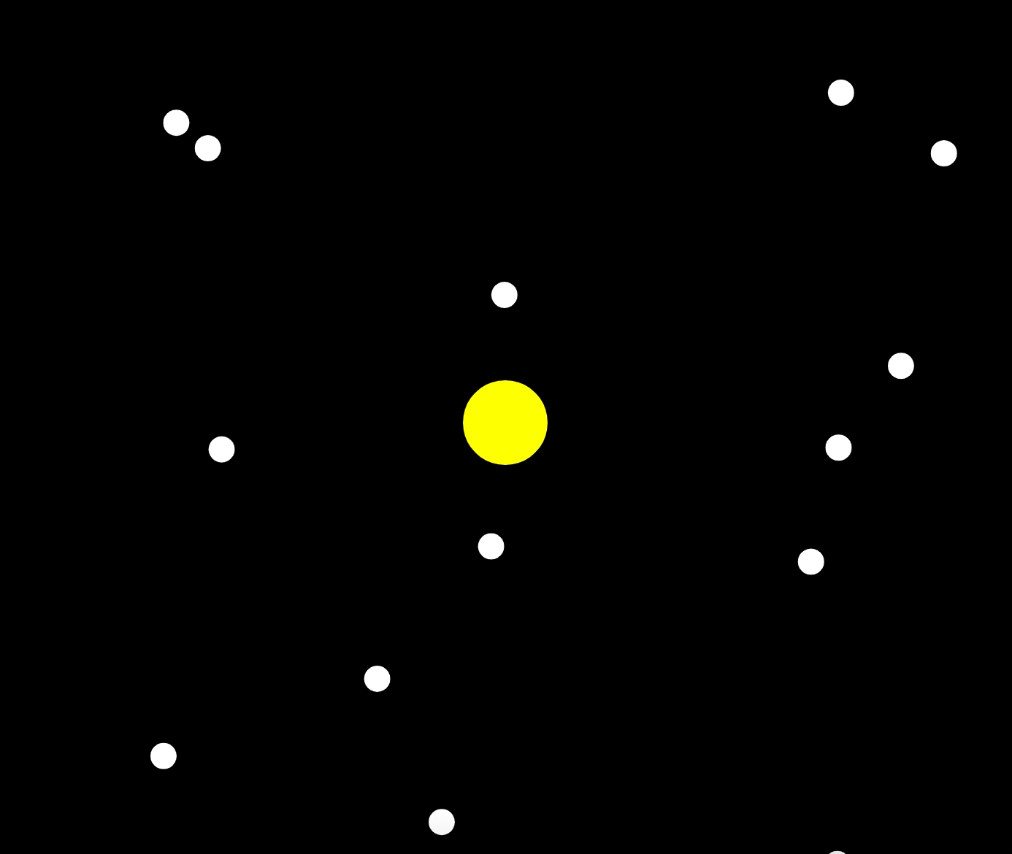Demo of my current code is shown below. (Link: <https://editor.p5js.org/hshwbkashbdjbkas/sketches/1nrsiCfuf>). (Copied over to a version called Visual-Forces, 12/04, <https://editor.p5js.org/hshwbkashbdjbkas/sketches/02OOjnBOG> , and used in week 12 immediate combination)

Video file name: POC DEMO VIDEO.mov

Each particle creates sound as they collide, user can click and create a particle but only 1 (need to get this working).

Next thing I want to do is allow users to input their own Audio. I am going to work on this in a separate patch and then combine them. There are I couple approaches I have in mind to explore to create this functionality. Do I let users write a file? Might I need to utilise buffers?

I first found Coding train microphone input video (<https://www.youtube.com/watch?v=q2IDNkUws-A>). This video explained how to get audio into JavaScript using a computer’s microphone and also security and other issues surrounding audio such as that Chrome will ask users the enable the microphone. Also, he says – (00:01:25) – the page has to be hosted through htpps – secure – can say why I used p5.js – additional security and encryption. -Use local host? – no lag test.

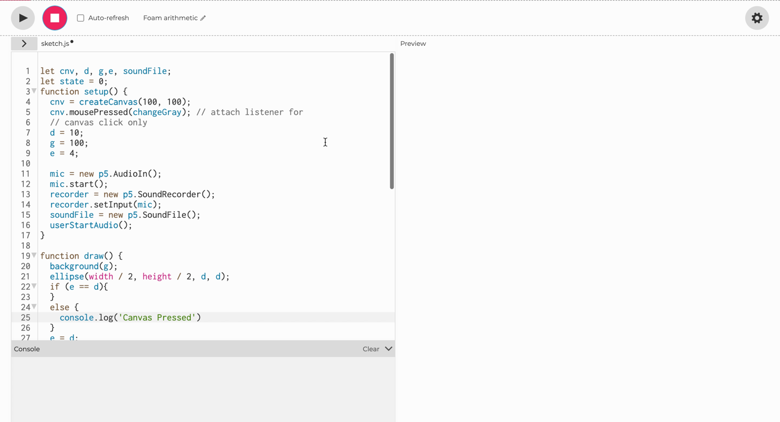The Coding Train video was useful however, it only explores analysing the amplitude of microphone input at a given moment using ‘mic.getLevel()’. I need to be able to record and playback audio in the webpage. I researched into the audio focused p5.js objects and identified ‘p5.SoundRecorder’. Which ‘Record sounds for playback and/or to save as a .wav file’ (<https://p5js.org/reference/#/p5.SoundRecorder>). The example code allows the user to initiate audio recording using a mouse click. The next mouse click stops the recording and a third mouse click plays and downloads the audio recording file. I used this example in combination with the ‘mousePressed()’ object example code to create the code below.

Video file name: Journal Video 3.mov

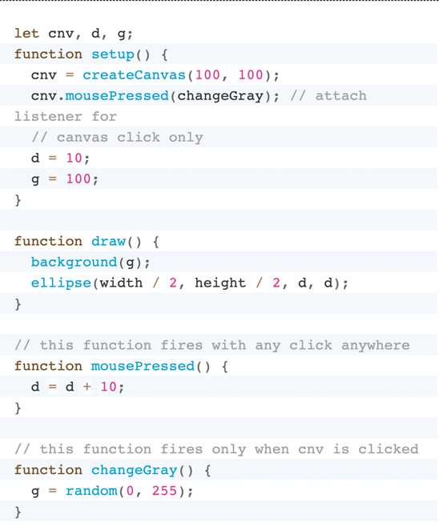Essentially inspired by the use of global variables in the ‘mousePressed()’ reference example code (shown to the right below), which were re-assigned values in the ‘mousePressed()’ and related functions, I incorporated this idea into the ‘p5.SoundRecorder’ reference example code. For example ‘d’ initialised to ‘10’ and ‘e’ initialised to ‘4’. In the draw loop I have an if else statement which determines if ‘e’ is equal to ‘d’. If they are not equal then a message is printed to the console ‘Canvas Pressed’ and ‘e’ is assigned the same value as ‘d’. Therefore, as draw continues to loop the conditional is true (‘e == d’) and no message is printed to the console. If the mouse is pressed and therefore ‘mousePressed()’ function run variable ‘d’ is increased by ‘10’ and therefore conditional in if else statement is false, ‘Canvas Pressed’ sent to console and ‘e’ is assigned ‘d’ variable value. This combination of the two reference example patches is important because it allowed me to using conditional if else statements determine if the mouse had been pressed within the ‘draw()’ function.

It was important to link back to the ‘draw()’ function because the ‘mousePressed()’ function is only run once when the mouse is pressed. I think linking this signal into the draw function will give me more control and I want minimal code locked away in that function because I won’t be able to recall it during the animation.

This was good but I want my code to create lots of new sound files as I’m going to have small microsound events. In the same way with ‘particles[]’ I changed the ‘soundFile’ variable into an array. I will be able to link this to the ‘particles[]’ array and also loop through it and create lots of different instances. In the ‘setup’ function I added the below code to create new sound files in the first 5 elements of ‘soundFile[]’.

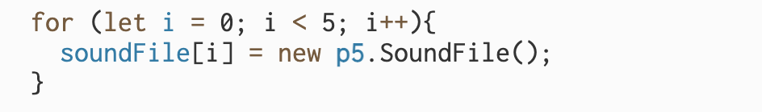

Next, I need a clock function, so that after x amount of time I can loop through the different sound files recording to each one. The plan was to use a for loop if statement combination for example using the index of the for loop in a multiplication and part of the conditional of the if statement to create specific time zones in which record into different elements of the ‘soundFile[]’ array. Finding clocking functionality turned out to be very simple. I found a clock example <https://p5js.org/examples/input-clock.html> and also a reference for the ‘millis()’ object <https://p5js.org/reference/#/p5/millis> which worked very well.

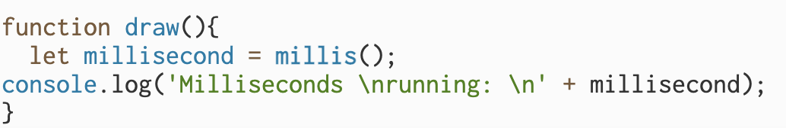

**Friday**

The issue I am having right now relates to the fact that once the mouse is clicked, I need my code to record into sound file (this is not what I’m having a problem with), then after 100ms (or 0.1 seconds) recording into that file is automatically stopped and a new file is opened and recorded into. I need the functionality for multiple files will need to be recorded into.

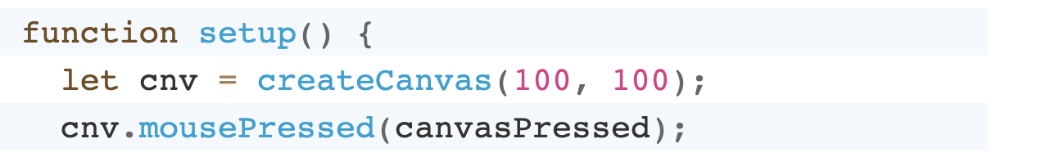In the Sound.Recorder reference which I have been using the ‘function canvasPressed()’ contains the code which records and plays the sound file. Also, relevant lines in the setup calling the function are shown below.

I will need to use this pairing of ‘.mousePressed’ and the function albeit probably in a button form. As the user will need indicate when they want to introduce new particles and therefore record new sound into the game.

Getting onto my problem is that I therefore need to automate the ‘recorder.stop()’ element of the code. In the example below, Audio recording starts on the first press, then stops on the second press. This is done by use of a global ‘state’ variable which is changed.

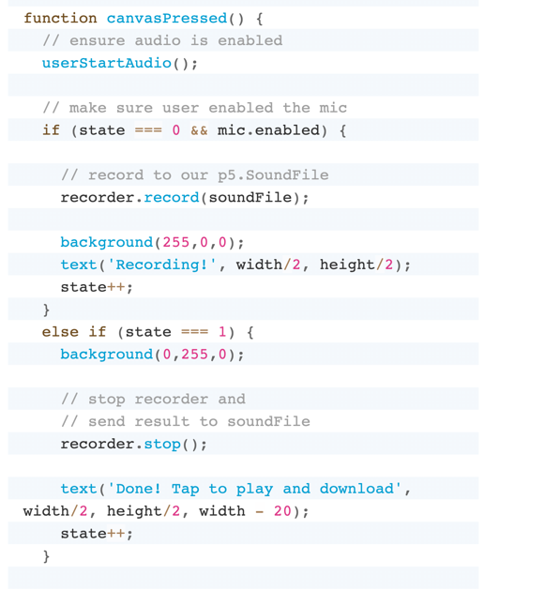

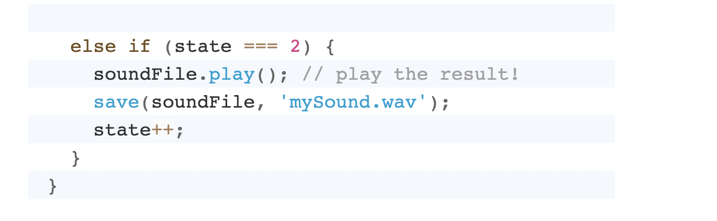

I needed to create some sort of timer function which stops recording into a file (‘recorder.stop()’) 100ms after it is started ‘recorder.record(soundFile)’. I started writing an if statement and thought I would assign a variable ‘let a = millis()’ if a is larger than 100 then stop the recording however through looking into the ‘record()’ object reference <https://p5js.org/reference/#/p5.SoundRecorder/record> I realised that one of the parameters was duration. Therefore, this clocking + if statement was redundant. I could easily set the amount of time that I wanted the audio files to be. Below is the code which I wrote.

In the initialisation I changed the ‘recorder’ variable to an array. I thought it would be safer for each element in the soundFile[i] array to have an independent ‘p5.SoundRecorder()’ object assigned. This is because if for some reason there was an erroneous overlap between recording files I don’t want this to cause glitches which may have been the case if one ‘recorder’ switches between files.

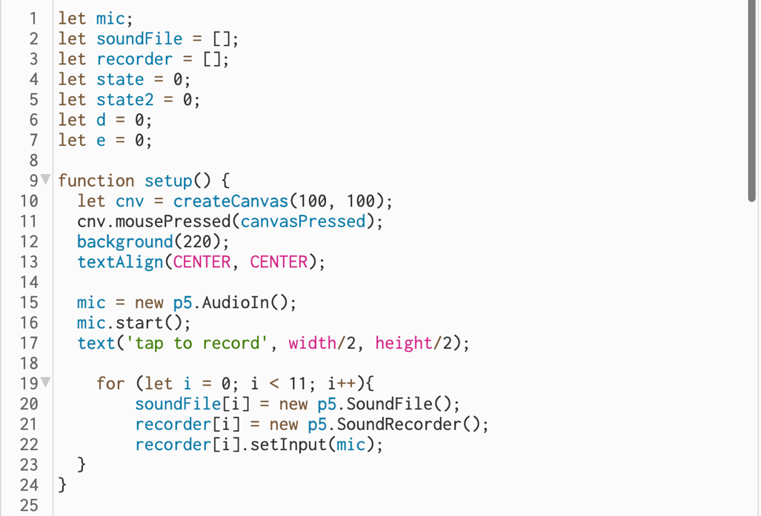

I subsequently included the ‘recorder[]’ array in the for loop initiating elements in the ‘soundFile’ array. For the same number of elements in ‘soundFile[]’ that a new sound file is opened a respective ‘p5.SoundRecorder()’ object is assigned into the ‘recorder[]’ array and the microphone is set as input.

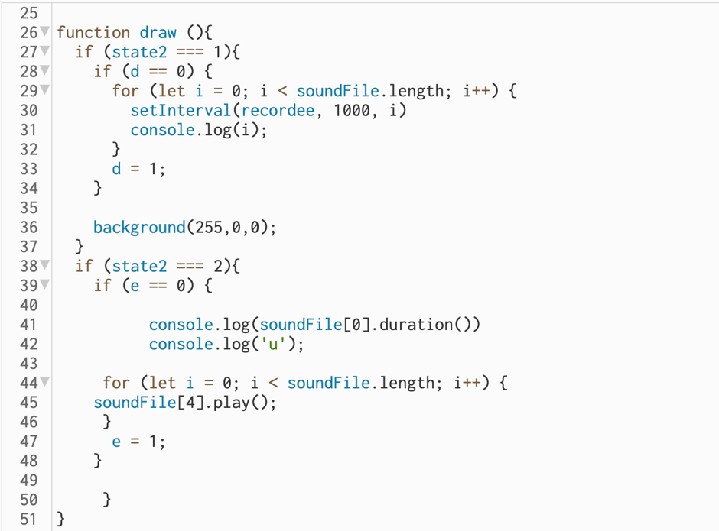

In the ‘canvasPressed()’ function I included the assigning of variable ‘state2’. State2 = 1 in recording (first mouse press), State2 = 2 for playback (second mouse presses).

Looking at line 28 first assume that the code included within the if statement records the audio in. The reason I have included this line of code and relatedly line 39 is that due to location of this code in the draw loop which is being repeatedly looped through and the fact that ‘state2 === 1’ being true for a period of time recording into ‘soundFile’ was repeatedly being triggered. Relatedly when ‘state2 === 2’ was true playback was constantly being triggered. This caused extremely strange audio to occur (Also I would get an error (‘NotSupportedError: Failed to execute 'createBuffer' on 'BaseAudioContext': The number of frames provided (0) is less than or equal to the minimum bound (0)’, this was occurring because the recording was constantly being triggered after ‘state === 1’ being true, my inclusion of the ‘d’ variable conditional only triggering record once stopped this error.).

The inclusion of if statements at line 28 and line 39 function to only trigger their encapsulated code once allowing e.g. audio playback to occur as it should. At the end of the if statements the variable being tested is assigned ‘1’ therefore the conditional is false, and the code does not run.

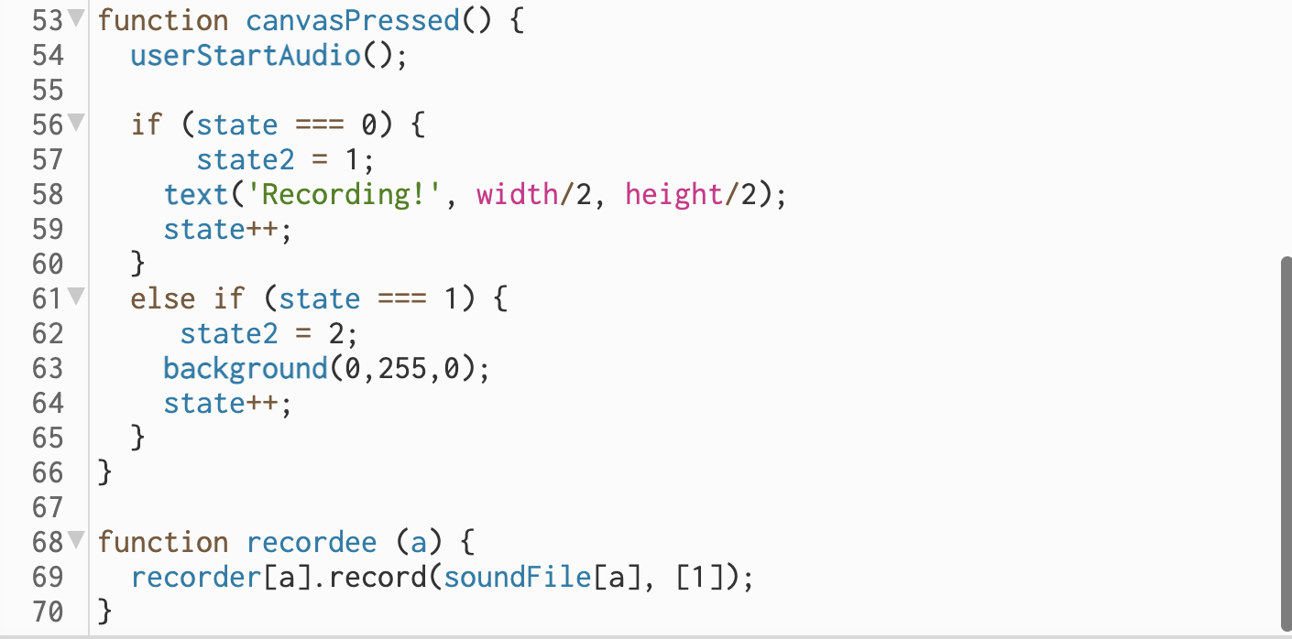

I then call the ‘setInterval’ function which is function which calls the ‘recordee’ function once a second. This ‘recordee’ function is used to record into the soundFile array. I use a for loop and pass the index into ‘setInterval’ and subsequently ‘recordee’ functions as a parameter. I use this to determine the element in ‘SoundFile’ array which is recorded into.

Previously I was not using the ‘setInterval’ function however on testing all elements in the ‘soundFile’ array were the same. Despite using a for loop to loop through they were all recording at the same time (the beginning when recording was actioned, the same part – Audio in all was the same). By introducing the ‘setInterval function’ each instance of ‘recordee’ is called at specific time intervals and recorded a specific period of time. This is exactly what I need in my game.

Just to note, some of the parameter numbers for instance the time of recording + call back for the ‘setInterval’ function and ‘recorder’ object will be smaller but it was more practical and clearer to test with larger time frames in the region of seconds rather than milliseconds.

**Week 10**

Next, I wanted to be able to exert some further control over user input audio before I collated this functionality (Audio modular section) into my wider particles patch. Given that my system is going to be recording loads of very small sections of audio and playing them back there could be a large issue with clicks and pops as audio files start and stop playback abruptly. This could aesthetically be extremely detrimental to my game. Therefore, the next thing I am working on will be to create envelopes or fade in and fade outs for the audio files. Also, given that it’s a very related topic, I am going to explore introducing the functionality for applying delays and reverb onto the audio files as this will also be important aesthetically.

I researched into the ‘envelope()’ and ‘ramp()’ object reference pages. Both of these examples used oscillators. Below I attempted to combine the ideas from these reference examples for use with an audio file (I separated out this idea from previous code where I was using sound files in an array to isolate the problem). However, the code did not work (it wasn’t returning any sound). It seems due to the way audio files and oscillators operate differently in p5 the solution may need to be modified.

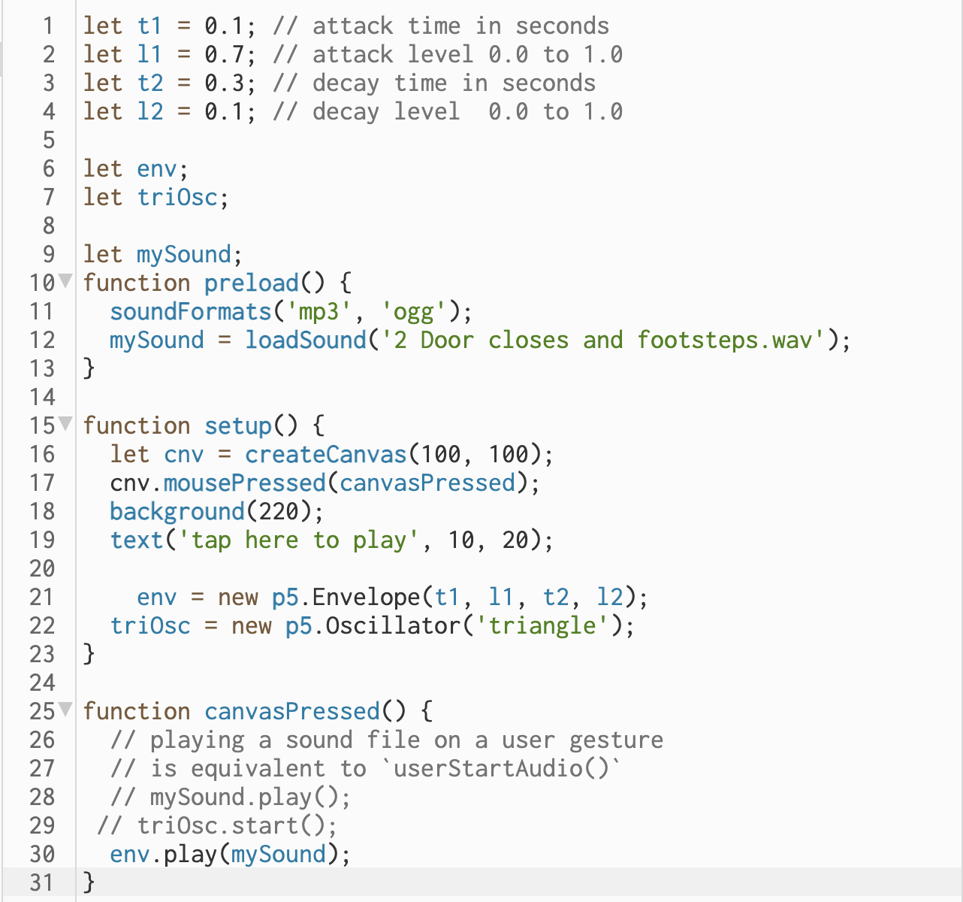

I have a feeling researching into the ‘amp()’ object might help. If I control the amplifier with the envelope this may fix my problem (I would be controlling the volume of the amplifier outputting the audio file not the audio file itself).

The below code works to create an envelope for the audio file as required with a fade in and fade out. Through looking into the ‘amp()’ object reference page I gained a better understanding of how the ‘envelope’ ‘ramp’ and ‘amp’ objects were working together and wrote the below code adapting the ‘ramp()’ reference example for an audio file. Key is that in the ‘canvasPressed’ function the audio file is set to play and then the envelope ‘env’ is acted on my the ‘ramp’ object. The audio file is playing and amplitude of the ‘env’ variable is changed by the ‘ramp’ object parameters.

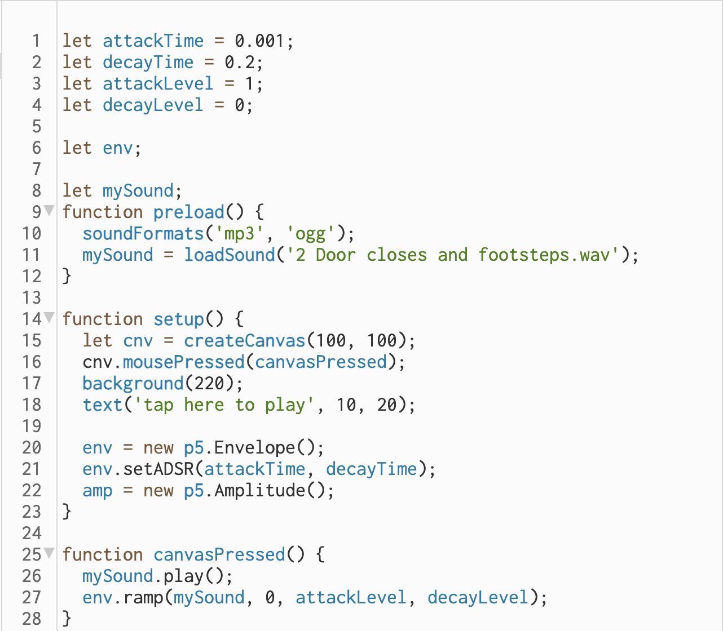

This works great and I will now implement it into the higher level of code to ensure that it works with multiple files. But first I also want to add reverb + delay.

I researched into the ‘p5.Reverb’ object reference page and looked at the example code. It was easy to incorporate this into the code above.

<https://editor.p5js.org/hshwbkashbdjbkas/sketches/ay6kQffJr> (ENV + Verb) shown below.

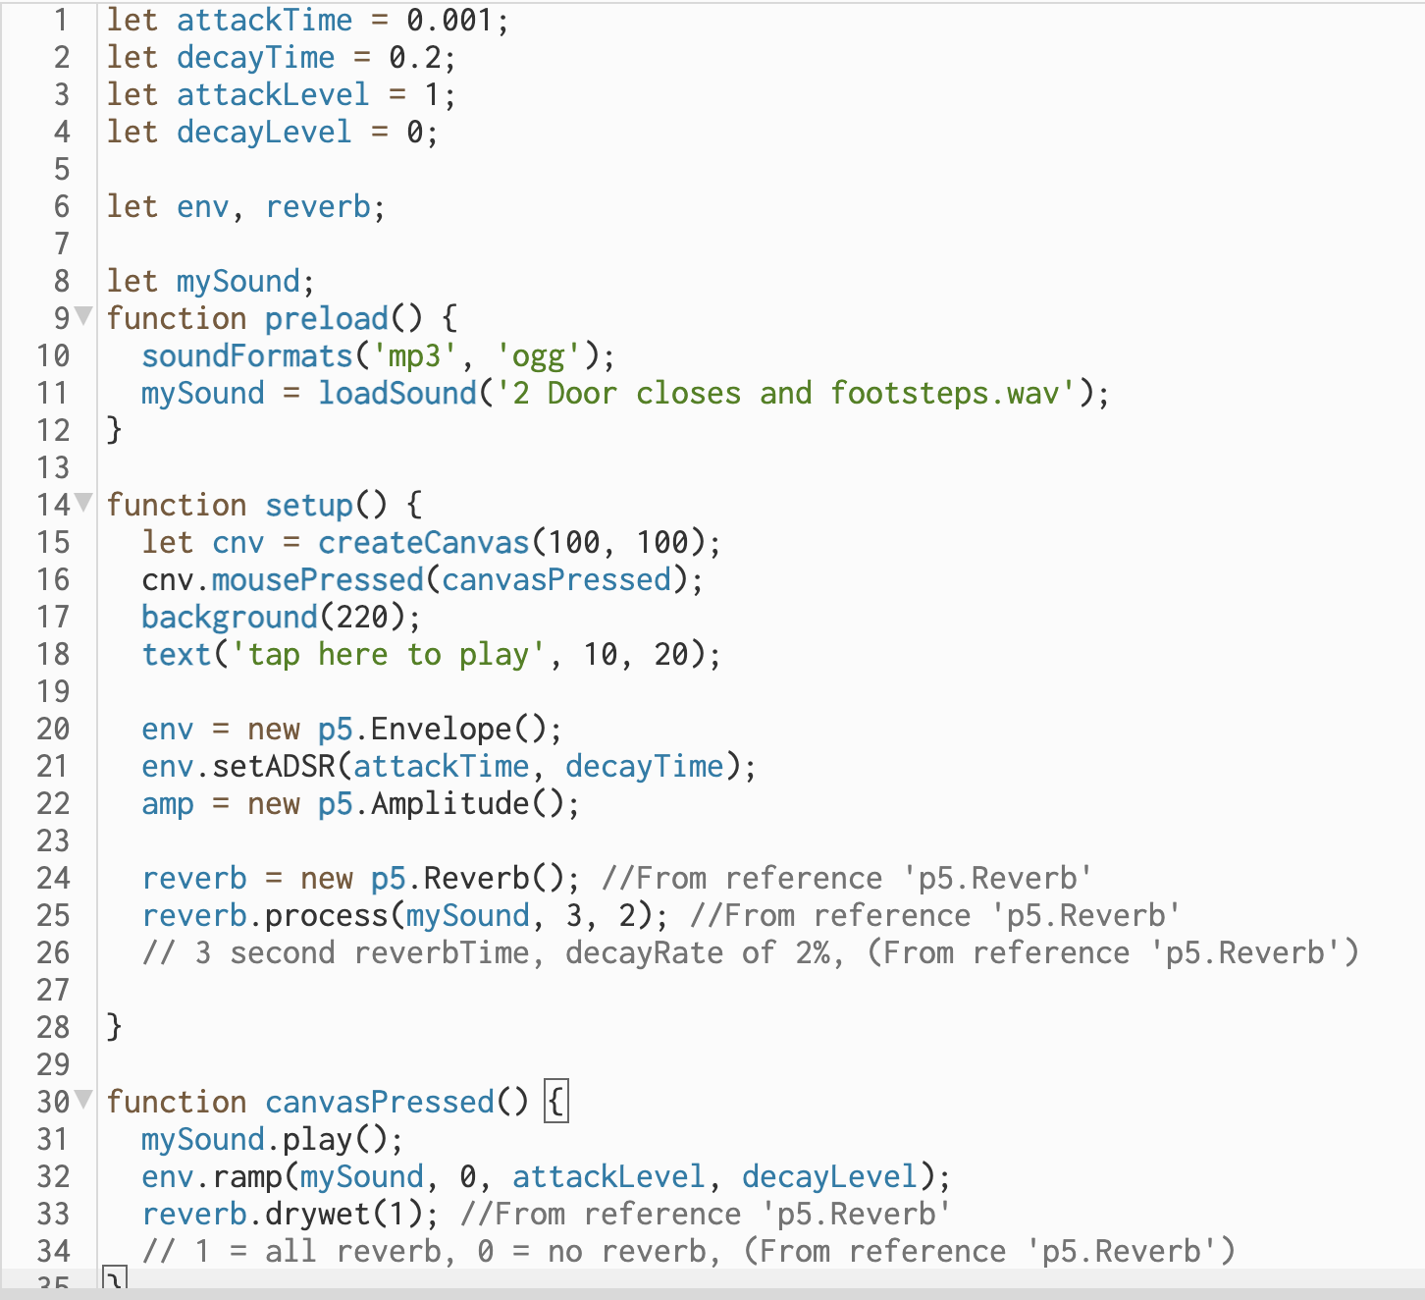

I then researched into the ‘p5.Delay’ object. As like with ‘p5.Reverb’ it was very easy to understand and incorporate these related objects into my code. All these three different elements, envelopes, reverb, and delay are shown combined in the code below (ENV + Verb + Delay). (Might need to go back and add in comments for ENV saying from ‘ramp()’ or other).

<https://editor.p5js.org/hshwbkashbdjbkas/sketches/4eAAezHt2>

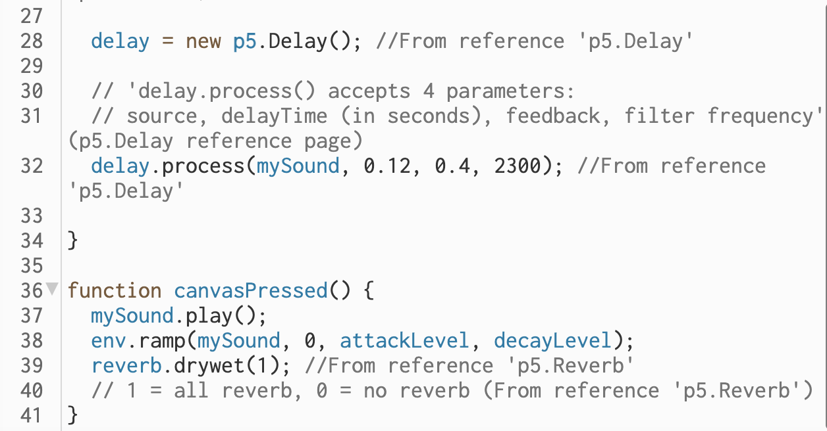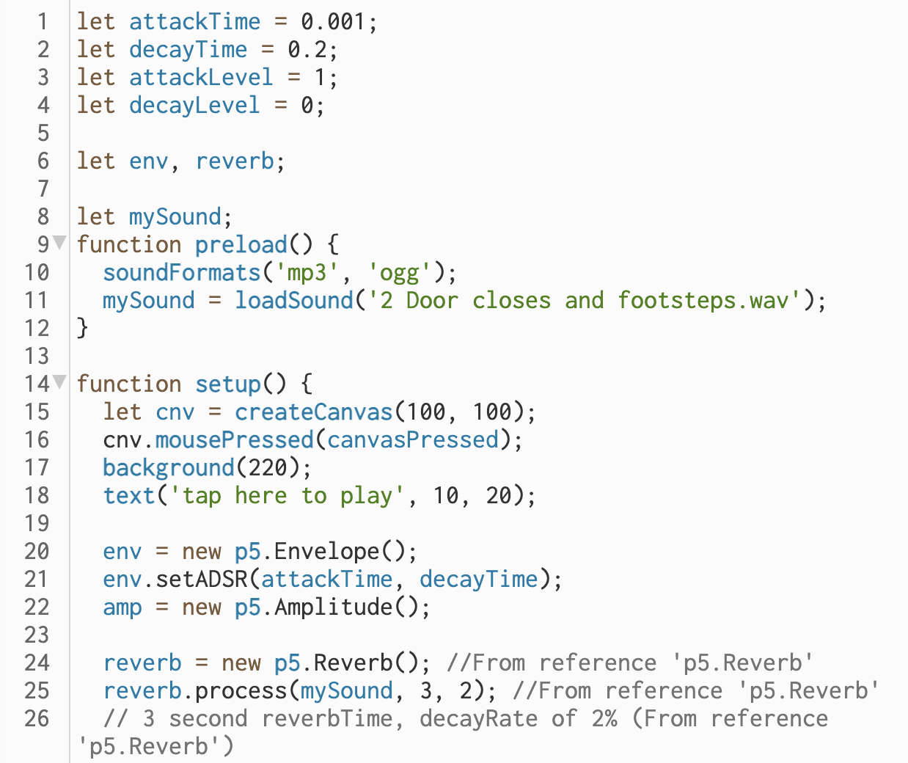

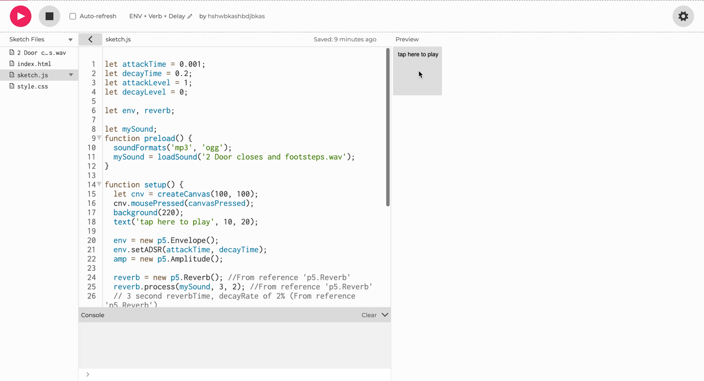Demo Video:

Video file name: ENV VERB DELAY DEMO TRIMMED.mov

Next, I’m going to take these ideas and implement them in the iteration one layer above this which included multiple Sound Files stored in an array (This is not the top-level iteration with the visual animation at this stage).

I am essentially incorporating the ‘ENV + Verb + Delay’ code (https://editor.p5js.org/hshwbkashbdjbkas/sketches/4eAAezHt2) into the ‘Array Sound Files’ patch (<https://editor.p5js.org/hshwbkashbdjbkas/sketches/0xd7UWiz6>).

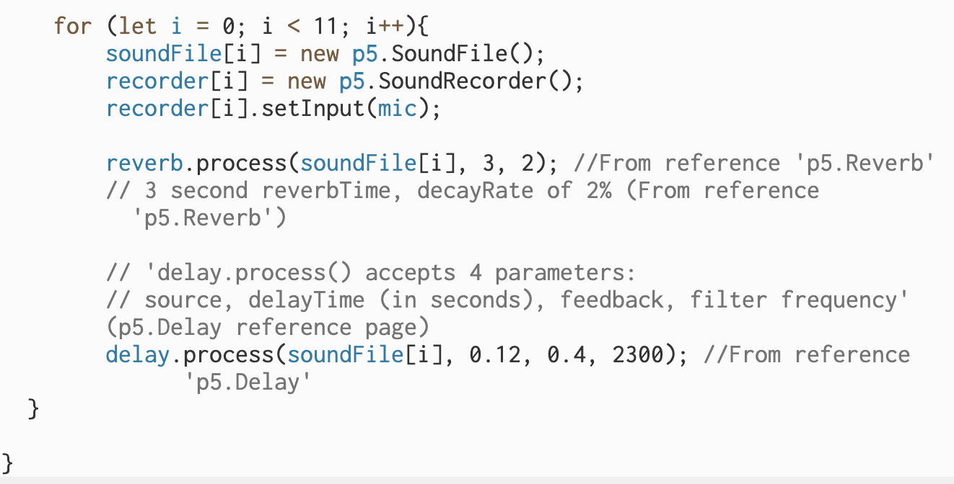I incorporated the initialisation of the global variables in the ‘ENV + Verb + Delay’ code and then move on to the setup function. I initialised envelope, amplitude, reverb, and delay objects and then moved on to the ‘reverb.process’ and ‘delay.process’ lines of code. Here is one point where I had to adapt the code. As one of the parameters for ‘reverb.process’ and ‘delay.process’ I have to state the sound file being processed. In the ‘ENV + Verb + Delay’ patch I am just processing one audio file identified by the ‘mySound’ variable whereas in the ‘Array Sound Files’ patch and the new combined patch, I will need to have the ability to process a range of audio files stored in the ‘soundFile’ array. Bearing this in mind, I actioned the ‘reverb.process’ and ‘delay.process’ lines of code within the for loop creating the different elements in the ‘soundFile’ array using the loop index ‘i’. I used this index ‘i’ as the part of the ‘.process’ objects parameters to instigate the required processing on entirety of the soundFile’ array.

Going to the playback section, first I removed the for loop which I had there. I had this for loop included as during testing I was exploring looping through playback of different files. However, this wasn’t necessary as I only wanted to playback one file at a time at this stage in development.

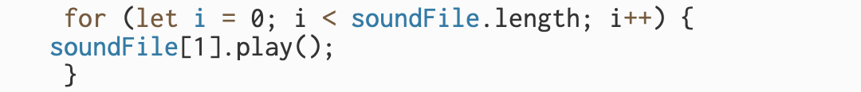

I added in the code shown below highlighted by the blue box. However, during testing, I was getting a lot of anomalous results. I would test [1] as the parameter record myself counting. Early in the recording should be been played back but it would often output sound from much later in the recording. I think the ‘env’ object was remembering its past envelopes and this was having an impact on accuracy of files played back. I thought a simple solution to this would be to separate out the envelopes into array so each element in the ‘soundFile’ array could have an independent envelope.

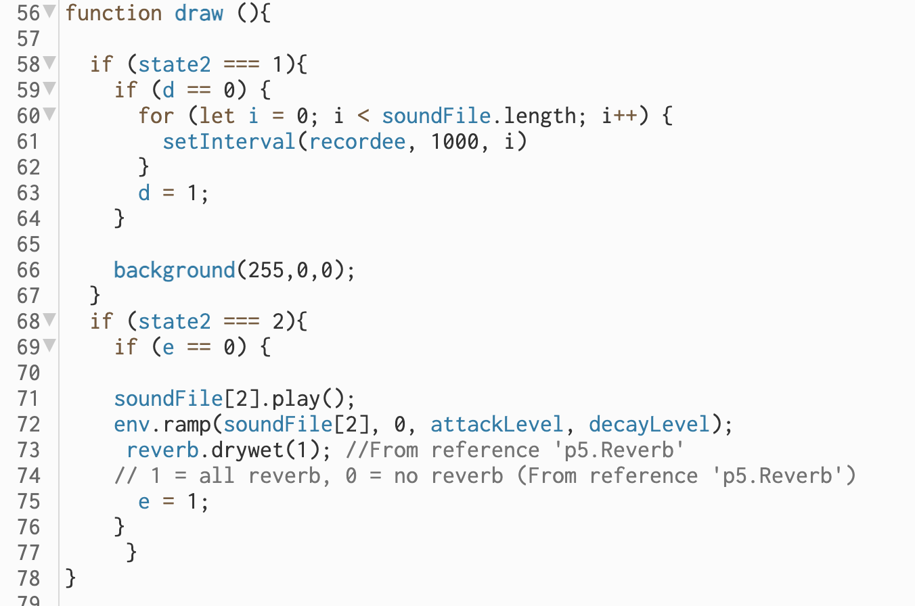

I initialised ‘env’ as an array and then assigned its elements new ‘’p5.Envelope()’ objects in the for loop in the setup function shown below.

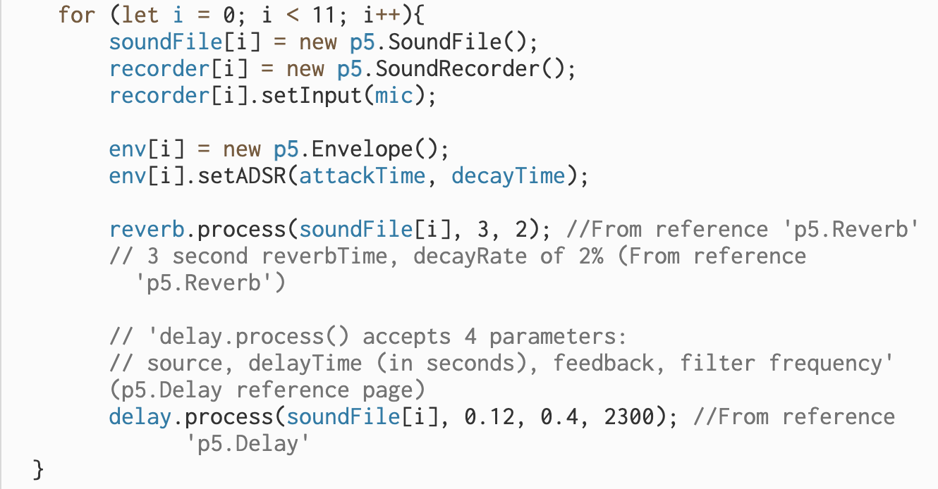

I then modified the code which I had written in the draw function below identifying the required envelope stored in the ‘env’ array for that respective audio file. This worked exactly as intended and removed the unpredictable temporary nature of what part of audio would be played.



Whilst experimenting at this stage I assigned the ‘attackTime’ and ‘decayTime’ variables to values centred around a 1 second audio file time to ensure I was clear in how the code was working. For example, if I was using much smaller audio clips it would have been much harder to identify if that the ‘env’ variable was causing a problem as it was. It is much hard to identify where small audio files come from (what point in the recording they are located).



I have now successfully collated these two patches and it works as intended with delay and reverb. The ‘Array Sound Files + ENV etc’ patch link:

<https://editor.p5js.org/hshwbkashbdjbkas/sketches/YRrTf_s4s>

**Week 12**

I have just returned from a break from working on my project. I know that previously to the break I had left myself in a good clear position so that it should be easy to continue with my previous work. I know that the next step in what I need to do is to combine the two main patches I have. Previously I had completed the ‘Array Sound Files + ENV etc’ patch with all the functionalities which I needed from it, and I know need to implement this code in the wider patch (‘Visual-Forces’) now. What I mean from this wider patch (‘Visual-Forces’) is the code visualising the particles utilising vectors I wrote in week 9. ‘Array Sound Files + ENV etc’ includes much of the sound focused code necessary for my final project. What I had in week 9 was very basic on the sound front. So, I am combining them to include all these sonic functionalities in the ‘Visual-Forces’ code. Both of these patches are fairly large with over 95 lines of code each, so I am going to work very slowly with continual testing adding in singular lines of code if necessary. I will do this in a new patch (‘Visual-Forces + Sound etc.’) to keep original versions separate. I will first copy in the ‘Visual-Forces’ code and then slowly work in the ‘Array Sound Files + ENV etc’ patch.

First, I copied over the global variable initialisations. Next, moved on to the setup function, here came my first problem. In the ‘Array Sound Files + ENV etc’ setup function I include the code below.

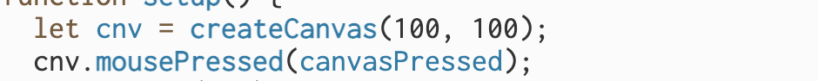

Assigns a variable to the canvas and when the canvas is clicked on the ‘canvasPressed’ function is called and therefore audio is recorded etc. In the interest of clarity, I think it might be an idea to use a dedicated button for this in the combined ‘Visual-Forces + Sound etc.’ patch. This is because if I am using canvas click for clicking in (spawning) particles and also changing record states this is confusing. I am going to edit the ‘Array Sound Files + ENV etc’ patch to use a button before continuing combining the two patches.

This was exceedingly simple. I researched the ‘createButton()’ object (<https://p5js.org/reference/#/p5/createButton> (Accessed: 12 April 2023). Identifying the lines of code I needed from the example:

button = createButton('click me');

button.position(0, 0);

button.mousePressed(changeBG);

I would then need to change the function called to the function that was being called previously when the canvas was clicked on ‘canvaPressed’. Shown below (commented code out to show it was removed):

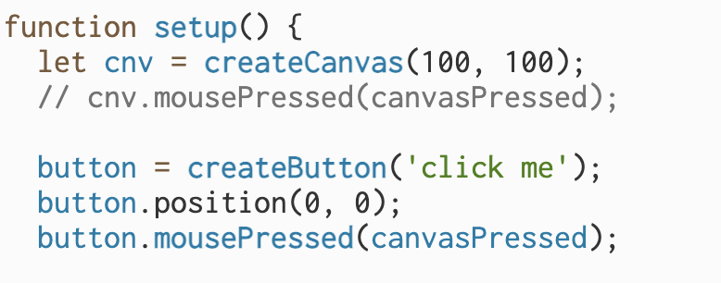

Also, I thought it was best to change the function name in the interest of keeping clear code. I changed it to ‘buttonPressed’. The edited version of the ‘Array Sound Files + ENV etc’ patch can be seen below: ‘Array Sound Files + Button + ENV etc’.

<https://editor.p5js.org/hshwbkashbdjbkas/sketches/lqSu3ZzbH>

This was easy to carry through to the ‘Visual-Forces + Sound etc.’ patch. I copied over the rest of the code from the setup after from about three lines which related to text and formatting (shown below) not necessary in the patch due to change to use of a button and for example ‘background’ already set in the ‘Visual-Forces’ code.

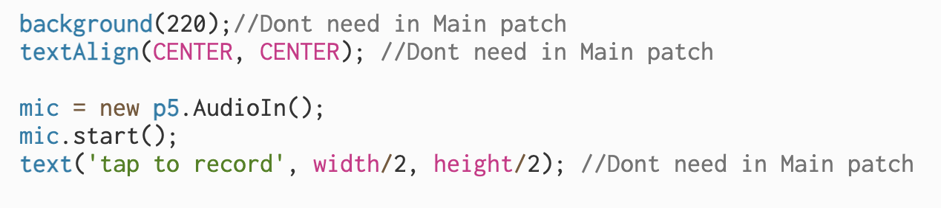

Now I had all the ‘setup’ code copied across I copied across the ‘draw’ code and the other functions. Upon testing when the button was clicked the whole screen turned red, this was because in the ‘buttonPressed’ function I change the colour of the canvas and also write text to the canvas. This will interrupt my particle visualisation, so I want indication of the user of recording etc. change the button itself. I wanted the text on the button to change when in recording mode. I thought this would be very simple. I tried changing the value (string) on the button using ‘.textContent’ as shown below but to no avail.

button.textContent = 'Recording';

After researching further into the problem, many examples I found suggested creating the button in the html or ‘index.html’ file, then assign this button to a variable using its unique ‘id’ and ‘document.getElementById’. It was then possible to change the visual text of the button using ‘.innerHTML’. Also, to note in the ‘index.html’ file button section I have (onclick="buttonPressed()") so that the ‘buttonPressed()’ function is called when the button is pressed.

The main source which helped me in this problem and which I used code from was *Baked Inhalf* answer in https://stackoverflow.com/questions/10671174/changing-button-text-onclick (Accessed: 13 April 2023).

However, these other sources also helped me understand the problem:

* https://sabe.io/blog/javascript-change-button-text (Accessed: 13 April 2023)
* https://bobbyhadz.com/blog/javascript-change-button-text-on-click (Accessed: 13 April 2023)
* https://www.w3schools.com/tags/tag_input.asp#:~:text=The%20tag%20specifies%20an,depending%20on%20the%20type%20attribute. (Accessed: 13 April 2023)

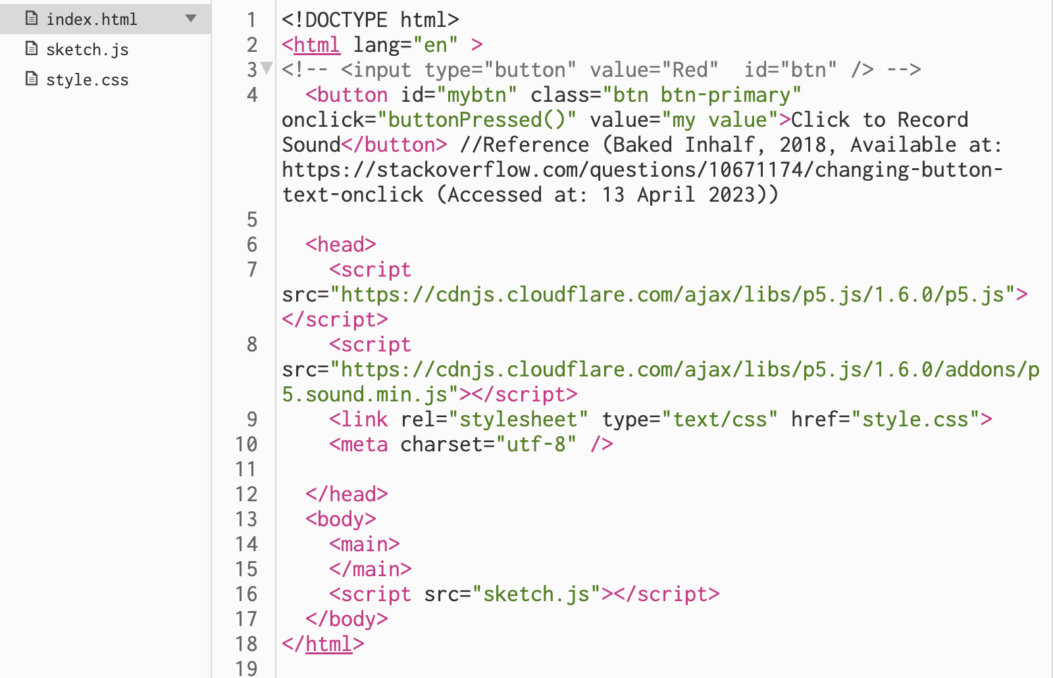

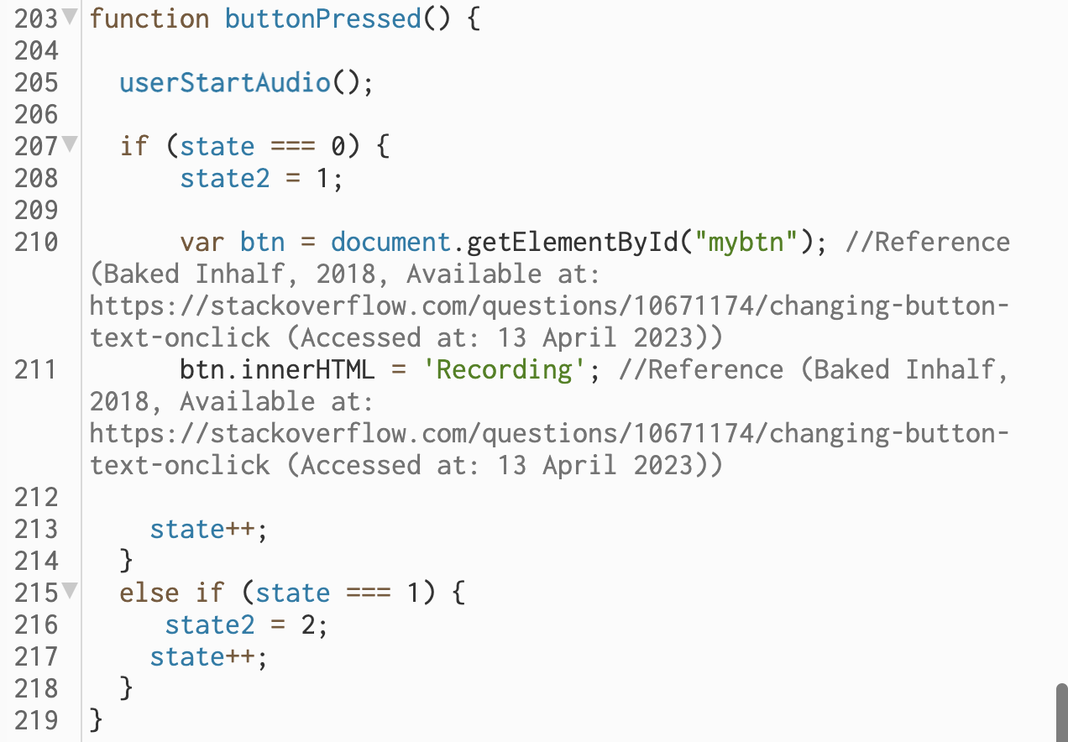

Full patch (Visual-Forces + Sound etc.2) Available at: <https://editor.p5js.org/hshwbkashbdjbkas/sketches/FZkwCBB7Q>

**Thursday**

Despite my progress on this button, I realise it is somewhat redundant. In my final project instead of a button I will much more likely be using some kind of stylised shape with text on it. Therefore, code similar to what I was using from the ‘Array Sound Files + ENV etc’ patch and original from the ‘p5.SoundRecorder’ (<https://p5js.org/reference/#/p5.SoundRecorder>) reference page may more be likely to be useful such as simple ‘text’ objects. Because of this I realise the button is more of a place holder until I reach the stylisation section of project development. I decided to strip back these changes I made and simply create a new button with the text I want before removing it. This is because I wanted to keep this place holder as simple as possible at this stage and prefer to keep all my edited code within the ‘sketch.js’ file. I feel most comfortable and that I have more control if I keep most things within the ‘sketch.js’ file at this point. I will edit the ‘.html’ file as and when it is really necessary.

Shown below I simply created a new button(‘button2’) overlapping ‘button’ when ‘button’ is pressed and then removed it upon the next click using ‘.remove()’. This source partially inspired me in the use of the ‘remove()’ object <https://codingbeautydev.com/blog/javascript-remove-element-on-click/> (Accessed: 13 April 2023)

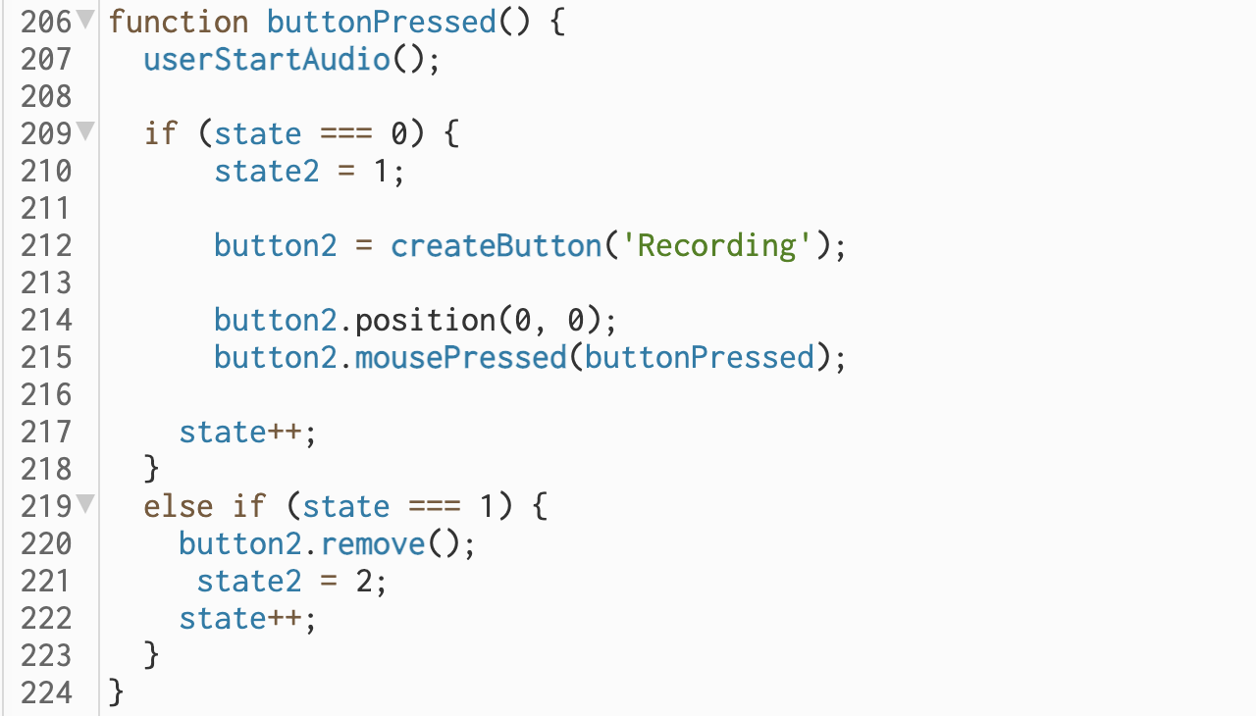

However, on testing upon clicking the button, I was spawning in particles. This is shown in a video below:

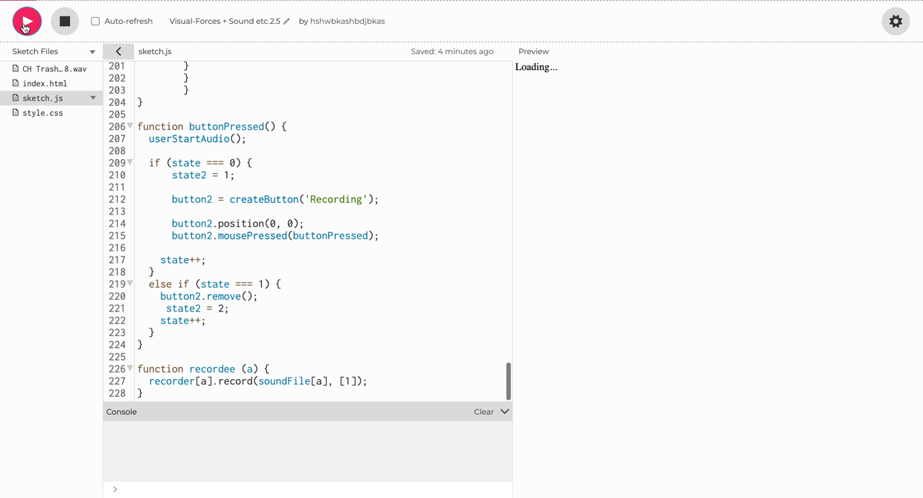

Video file name: Screen Recording 2023-04-13 at 12.29.23

To stop this, I first tested the x and y boundaries of the button using ‘console.log(mouseY)’ etc. I then implemented an if statement in the ‘mouseClicked’ function so that a new particle would not be created if the mouse was clicking the button. This will obviously need to be changed if I move the button.

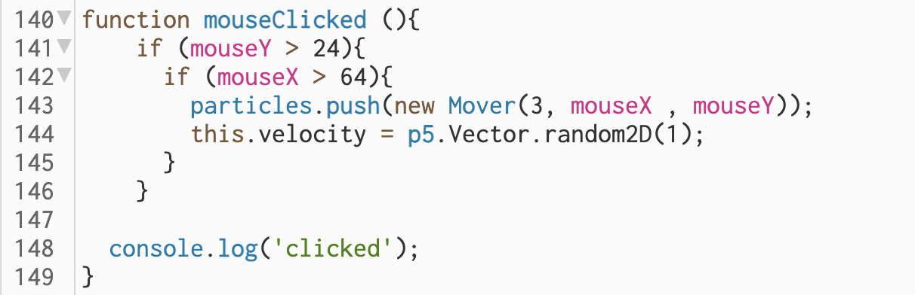

These additions can be seen in the ‘Visual-Forces + Sound etc.2.5’ patch:

* <https://editor.p5js.org/hshwbkashbdjbkas/sketches/0ZQdf21MG>

Now that that is all working as intended, I will move on to integrating the new recorded sounds into the particles. I’m doing this in a new version of the patch ‘Visual-Forces + Sound etc.3’. First, I think it is important to think about how this implementation is going to work at a game level and then break this down into programmable elements.

I think that the user should be able to click a button to enable recording, record the audio which they want, then click the button to stop audio. This first stage has already been implemented. Then the user should be able to click in particles each particle clicked in being attributed a 0.1 second section of audio from the recording which is played upon collision with other particles. For instance, the first particle clicked in after a recording will generate or spawn in a particle with a sound file taken from 0.0-0.1 seconds of the recording. The third particle clicked in will have a related audio file from 0.2-0.3 seconds of the recording. I already have the functionality to click in particles and also split up the recording into the required sections. I now need to connect these two principals.

To note during this stage of development, I’m going to use 1 second segments rather than 0.1 so that I can problem solve more effectively and ensure it is working as intended.

Currently sound is being output on particle collisions within the ‘CollideSearch’ function. Within this function, if particles collide(coordinates intersect) then ‘samp.play()’, ‘samp’ variable contains my high-hat sample. I need depending on the particles colliding different audio to play.

To note I changed the for-loop index parameters in the ‘reset’ function so that no particles are loaded on the running of the patch, they are only clicked in.

Right now, I have the idea to create a ‘particlesAudio’ array which will match up to the ‘particles’ array for example index 1 in ‘particles’ array upon collision index 1 in ‘particlesAudio’ array is played. I plan to append from ‘soundFile’ array onto the ‘particlesAudio’ array upon clicking and therefore the generation of particles. This keeps ‘soundFile’ array and ‘particlesAudio’ array separate which is useful. Important to keep recording and playback areas separate. I also need to cycle through ‘soundFile’. The reason it is important to keep ‘soundFile’ and ‘particlesAudio’ arrays separate is that the ‘soundFile’ array may be consistently re-written as different audio clips are recorded. However, in the ‘particlesAudio’ array specific sound files are committed, and essentially saved for a ‘playthrough’, to specific particles. The ‘particlesAudio’ could similarly be thought about as an element of a ‘particles’ class however, I’m keeping it more separated out because I prefer this way of working. Essentially the idea is at this stage is to assign element(s) in the ‘particlesAudio’ array to element(s) in the ‘soundFile’ array within the ‘mouseClicked()’ function and then using the for loop and its ‘i’ index number within the ‘CollideSearch’ function to playback the required elements from ‘particlesAudio’ when required (on collision). The recorded sound is committed to specific particles upon spawning in on the mouse click.

**Friday**

Before I implemented this plan, I decided to do a bit of a lower-level test. For this I removed ‘samp.play()’ within the ‘CollideSearch’ function and replaced it with ‘soundFile[2].play()’. This replaced the original high-hat sample which was being played on particle collision with a one second audio file taken from the middle of the user recording. To note, now on each run of the game I had to press the button record in some audio for a few seconds, press the button to stop recording and then click on the canvas to generate the particles.

I did this to create an initial link between recorded audio and that generated upon particle collision. However, all the particles still output the same audio on collision, this same 1 second, but it is now from the user input.

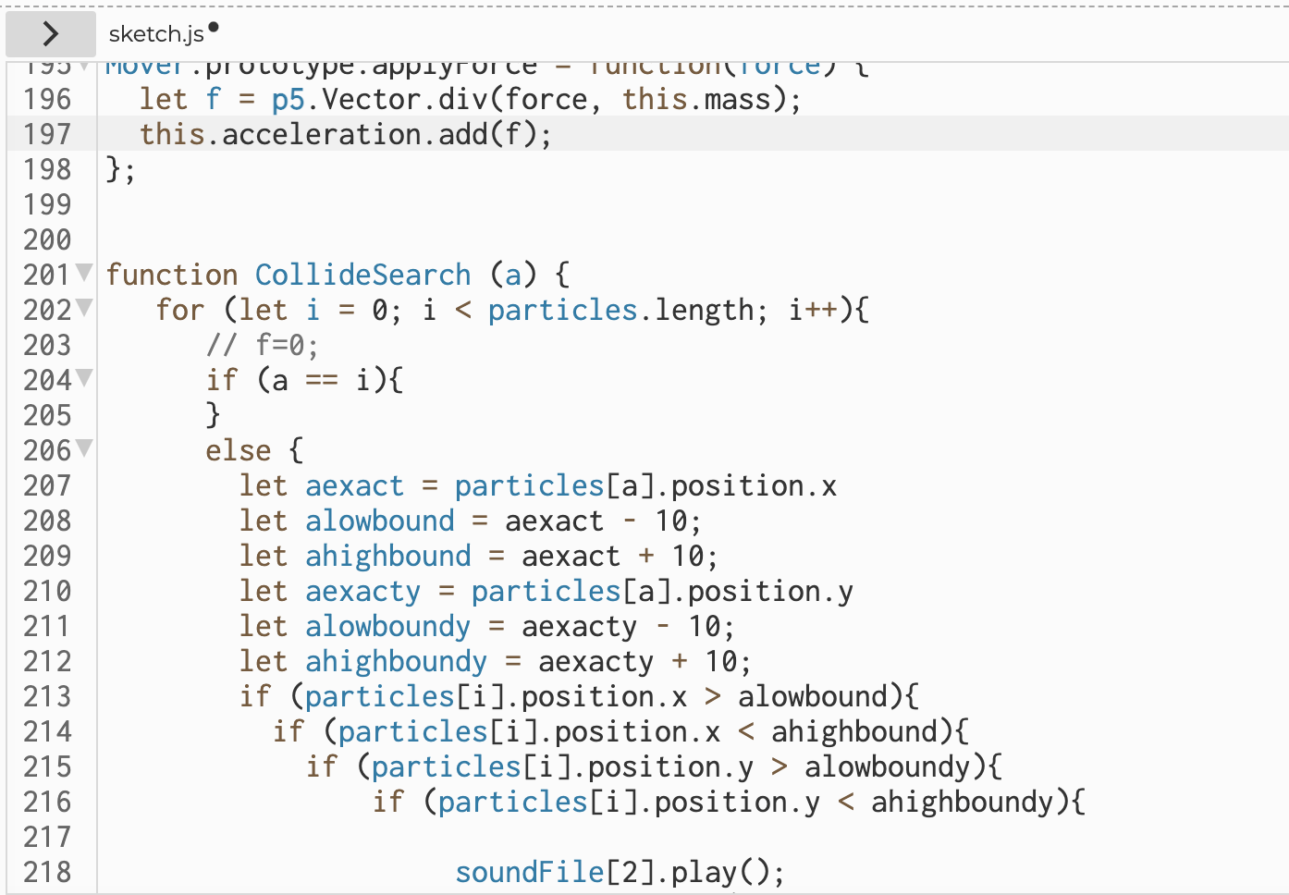

When I tested this, I noticed something strange; the audio didn’t sound right. At times it was coming through quite distorted and sometimes it didn’t play as required. I tested printing to the console at the same point where I was playing the audio file and I realised that I was receiving multiple ‘bangs’ for each collision this was triggering the ‘soundFile’ playback to occur multiple times for each collision causing unexpected sonic output. This was a problem.

Below is a video showing a demo at this stage and there is also a link to the code. In the video note the repeated duplicated collisions indicated by the console log. Also, just to note at this stage I commented out unnecessary effects such as the delay to problem solve.

Code (Visual-Forces + Sound etc.3.1): <https://editor.p5js.org/hshwbkashbdjbkas/sketches/OD_a5p9_q>

The video below was recorded on a phone due to technical difficulties at this time.

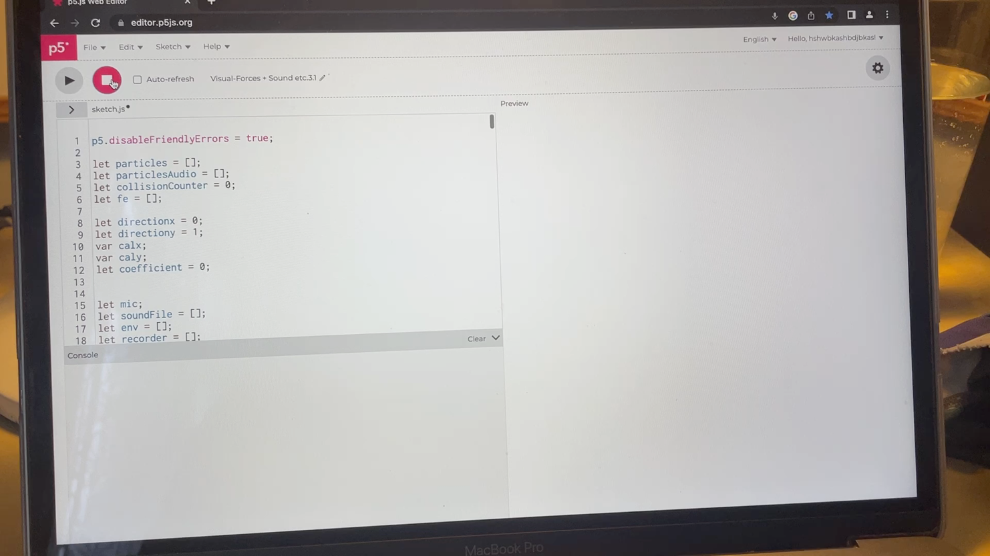

Video file name: IMG_4388.MOV

It is clear the patch is not working as intended and the sound file playback is not working correctly. I think this is in a large part due to the fact that the sound files are being over triggered with the duplicated collision signals. Therefore, it is very important to fix my ‘CollisionSearch’ function so that only one signal for each particle involved in a collision.

Initially, I thought the issue was due to the fact that the checking of collision was done in a coupled for loop. A for loop calling a function ‘CollisionSearch’ in which there was another for loop. I thought that when the coupled system inevitably loops back round e.g., a=2 and I = 4, after each loop works through its index and a=2 and I = 4 again then another collision will be detected simply because the positions of the particles match up and the inline if statement in ‘CollisionSearch’ is true.

Therefore, I knew that I had to create some sort of functionality that identifies if the collision has already been detected. I created an array ‘fe[]’ to do this. It was critical that this was an array because each index in the for loop needs its own independently stored value. If I used a variable, it would constantly be being overwritten when storing a value for different indexes in the for loop.

The logic at this stage was that each index in the for loop would have a respective ‘fe[]’ element. All elements in the ‘fe’ array are set to 0 in the setup function. Then within the ‘CollisionSearch’ function I determine if the respective ‘fe[]’ element is ‘0’ for a given loop if it is collision is detected and ‘fe[]’ for that index is set to 1. Only when the parameters of the wider (particles coordinates are the same) if statement are not true then that ‘fe[]’ element is set to ‘0’ allowing it to possibly trigger a collision again. Therefore, the particles have to be out of collision before they can retrigger a collision. This code can be seen below. To note, I collated all of the previous encapsulated if statements into one utilising ‘&&’ this made the if else relationship much simpler.

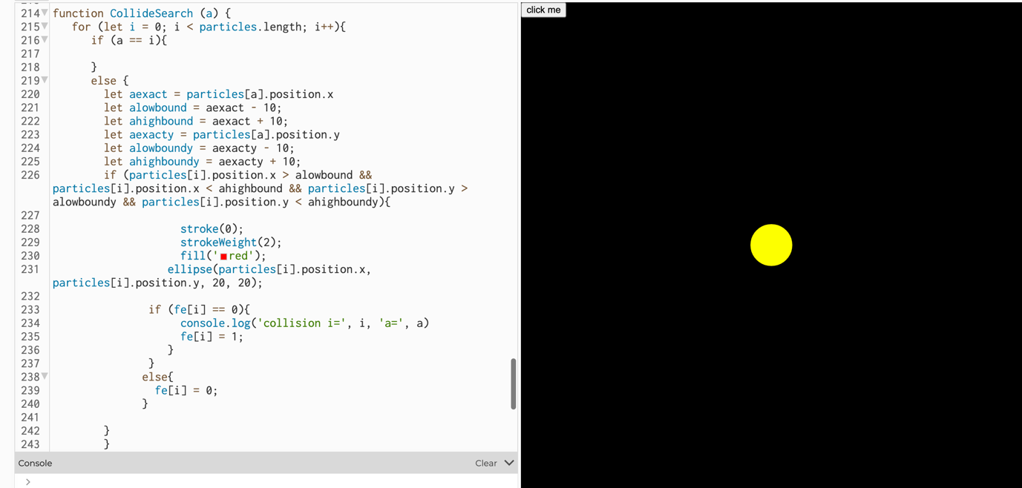

This code can be seen here: <https://editor.p5js.org/hshwbkashbdjbkas/sketches/aESSpT3oH>

However, it was not working. I was still getting duplicated collision signals which was really perplexing. I spent a lot of time printing different variables to the console log at different points in the code to really understand what was going on. I thought about potential workarounds such as using set very short intervals for this collision detection as the duplicates by their nature occurred almost instantly after the original signals.

However, this is an integral part of the system design which I wanted to work extremely reliably also using set time periods could cause problems if multiple collisions are occurring quickly.

One solution which I attempted to develop extended the code and attempted to identify if there were any ‘1’s in the ‘fe’ array.

Code: <https://editor.p5js.org/hshwbkashbdjbkas/sketches/s_T17iD1y>

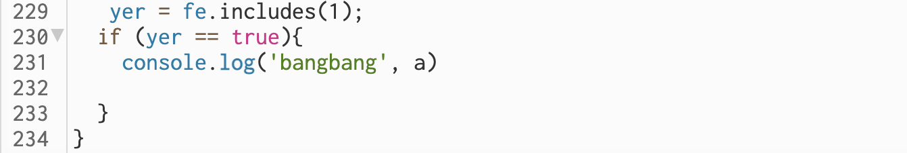

However, this had the same problem with duplicate signals. I decided to abandon this solution in particular because looking at ‘fe’ didn’t make sense. I would have to be clearing ‘fe’ to remove ‘1’s and that pathway didn’t make any sense and was using the variables in unintended ways.

**Saturday**

I had a revelation, I realised that the reason my code was not working was because due to the fact that I am using two coupled for loops each element in my ‘fe’ array is essentially being wiped as the for loop calling the ‘CollideSearch’ inputs different numbers into the index. For instance, when a =1 each element in ‘fe’ is stored safely and can be attributed to each index in the inner for loop but when a=2 this each element in ‘fe’ is being attributed collisions of a different set of particles e.g. checking particle 3 against all other particles. Therefore, when the two for loops come full circle and a=1 again values for ‘fe’ have not been stored meaning that my if statement determining if ‘fe[i]’ is ‘0’ or ‘1’ doesn’t work and duplicate signals occur.

How I am going to fix this is by ensuring that despite there being two coupled for loops each element of the ‘fe’ array is independent across this, e.g., ‘a’=1 and ‘i’=2 independent from ‘a’=2 and ‘i’ =2.

The code I wrote can be seen here: <https://editor.p5js.org/hshwbkashbdjbkas/sketches/ittbiY8Dn>

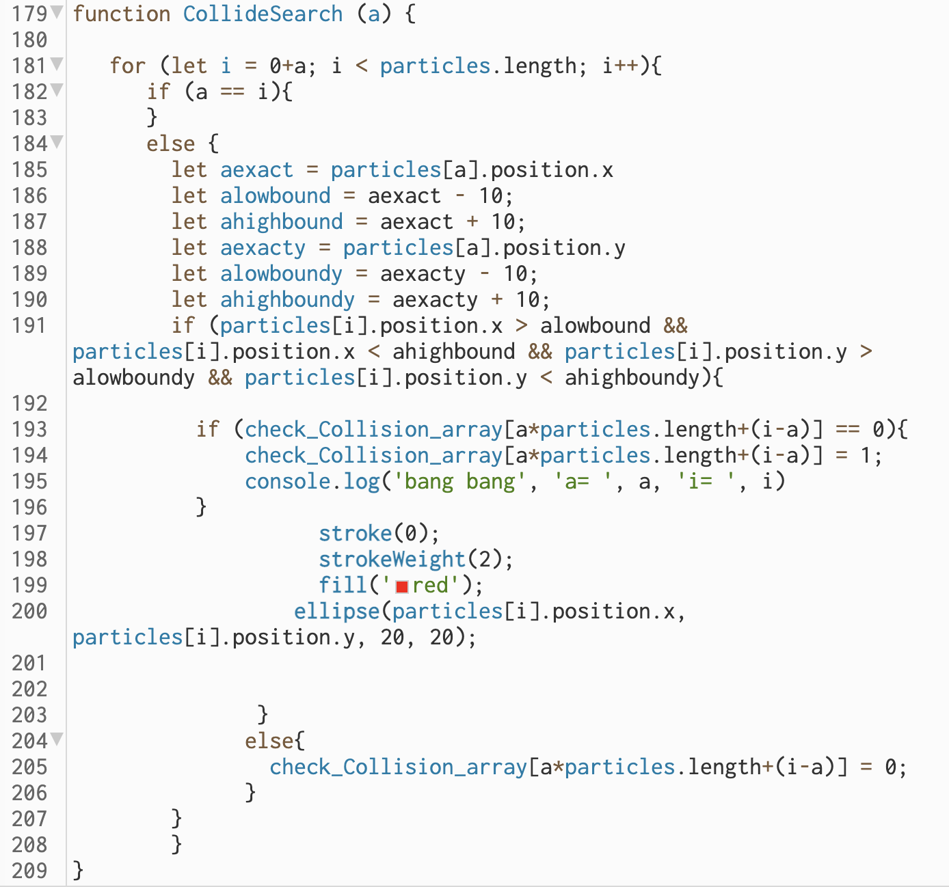

The changes I made where within the ‘CollideSearch’ function. First, I changed the for loop index parameter to ‘let i = 0+a’. This reduces redundancy for example when a=0, I =0 and checks through all other particles for collision.

But when ‘a=3’ ‘i’ will start at ‘3’ this is because if there is a collision ‘a=1’ ‘i=3’ then this will have already been picked up on the ‘a=1’ loop. Therefore ‘i’ doesn’t need to test against particles lower in order than the current. This decision increases efficiency as I’ve removed a large quantity of essentially repeats.

To note I changed the name of the ‘fe’ array to something more practical and clearer ‘check_Collision_array’. Then the key differentiator that solved my problem was parameters used for the ‘check_Collision_array’. I used the parameter ‘a*particles.length+(i-a)’. By including ‘a’ the index from the outer for loop passed through the function as a parameter I allowed myself to create unique positions in the array which were not overwritten. For example, for a particles.length of ‘10’ a=0 would occupy a range of elements from ‘check_Collision_array[0]’ – ‘check_Collision_array[9]’ etc. The inclusion of ‘particles.length’ in the equation means that the function is flexible to a change in this number. ‘i-a’ is included as I set ‘i=0+a’ this cancels out to what would normally be ‘+i’ and adds on the index of the for loop and incrementally works through the ‘check_Collision_array’ (+1) as ‘i’ increases for a specific ‘a’ value. For example, ‘a = 1’ ‘i=2’ would have ‘check_Collision_array[12]’ as a unique element for a particle.length of 10.

This fix works really well and I’m very happy with it. Now collision signals are not duplicated, and I should have no problem implementing the sound back in.

Below is a video showing how the collisions are detected as required. A collision is signalled by a message to the console log ‘bang bang’. The two particles involved are represented by a= and i=. For instance, if ‘bang bang a=0 i=2’ The first particle generated particle ‘0’ (index in particles[] array) and the third particle generated particle ‘2’ (index 2 in particles[] array) have collided. Index starts from 0. There is no audio in the demo shown below because it is not of focus currently.

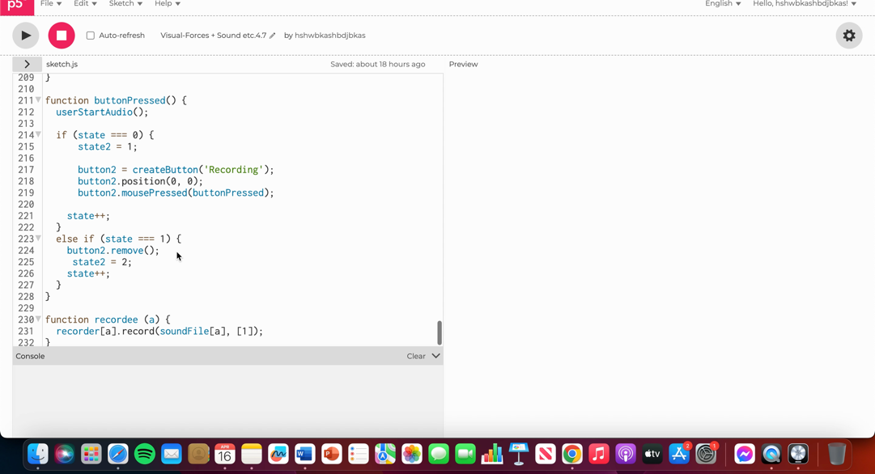

Video file name: Screen Recording 2023-04-16 at 10.45.06.mov

**Sunday**

Now that I’ve removed the issue of duplicated collision signals, I should be able to get the audio working as intended. I intend to just below the ‘bang bang’ log message to use ‘i’ and ‘a’ to play the required elements in the ‘soundFile’ or actually ‘particlesAudio’ arrays such as shown below (haven’t actually got ‘particlesAudio’ array set up properly yet):

**particlesAudio[i].play();**

**particlesAudio[a].play();**

But first I want to be methodical and test at a more base level. I tried testing from the ‘soundFile’ array, but the sound output was wrong (the sound output was from much later in the recording).

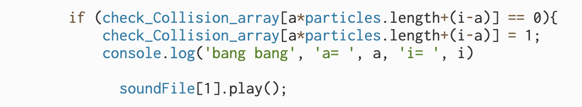

I noticed that even the ‘soundFile[0].play()’ I had in the draw loop which plays after recording is stopped by the second press of the button played the wrong sound (code lines shown below). Given I specified the first position in the array I was hearing back at a much later position in what I recorded in.

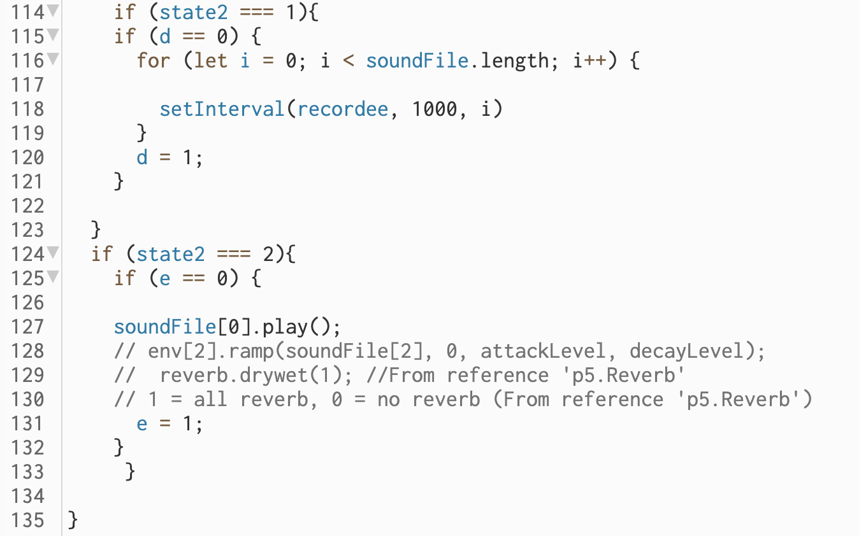

Through my own initiative and confirmed using console log messages ‘triggered’ within the ‘recordee’ function, I knew that this function is being ‘over’ called and therefore, this is what was causing elements in the ‘soundFile’ array to act unexpected and be overwritten.

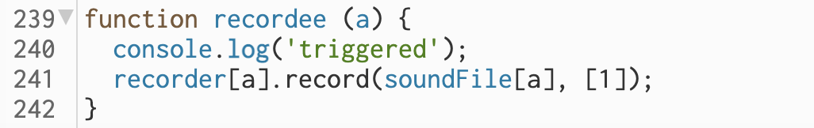

I had the code shown here: <https://editor.p5js.org/hshwbkashbdjbkas/sketches/yG1o-M-4u>

The image below shows the section of code used to call the ‘recordee’ function and record into the ‘soundFile’ array.

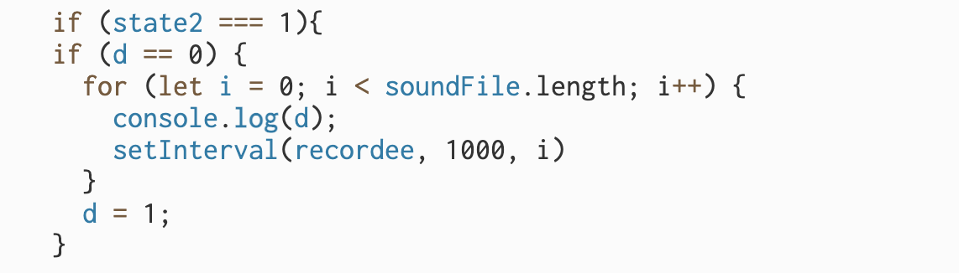

Through printing to the console log, I knew that on each set interval (for each one second) the ‘recordee’ function was called 11 times (length of ‘particles’ array). This is the reason that elements in the ‘soundFile’ array are not output as expected. On each interval (each second during recording) every element in ‘soundFile’ is overwritten with that 1 second sound file. This is why all why upon output all ‘soundFile’ elements sound the same as all only contain the last second during which record was enabled.

Whilst I thought that the for loop in combination with ‘setInterval’ would act to iteratively enter the next index of the for loop upon calling the ‘recordee’ function at intervals of 1 second my logic was flawed and the for loop runs through its index almost instantlously and is actually calling ‘11’ different instances of the ‘recordee’ function at set intervals of 1 second. Therefore these ‘11’ different instances are constantly overwriting there respective ‘soundFile’ element on each new callback (every 1 second).

I researched into the ‘setInterval()’ global function to gain a better understanding of it. What was particularly useful was the source: https://developer.mozilla.org/en-US/docs/Web/API/setInterval (Accessed: 16 April 2023). I took a section of code from this source and implemented in into my patch. I also look at: <https://stackoverflow.com/questions/17883692/how-to-set-time-delay-in-javascript> but it wasn’t as directly useful.

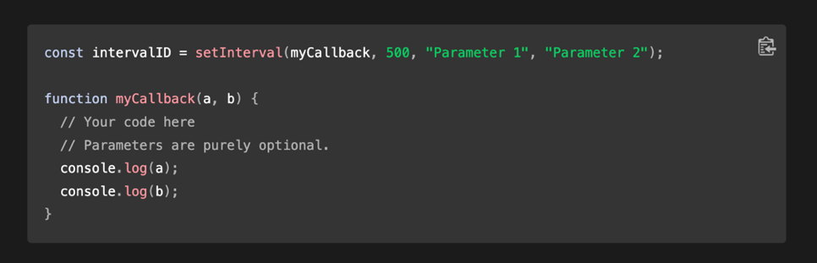

The example doesn’t particularly relate to my project, but I copied across the function + ‘setInterval’ callback anyway to make sure the correct syntax was there, and I was thinking about it in the right way. I thought assigning the ‘setInterval’ function to a variable is a good idea but I will not make it constant as the parameters might need to change. I also realised I don’t need for loop. I can use a global variable (q) instead of the index (i) from the for loop as a parameter in the ‘setInterval’ function and then increase this by one in the ‘myCallback’ function. This is the parameter used to indicated what position in the ‘’soundFile’ array is being recorded into. Code below shows how I tried to implement this:

<https://editor.p5js.org/hshwbkashbdjbkas/sketches/ZnWel6yxJ>

However, it wasn’t working as required. This was clear from the fact that when I printed ‘q’ to the console log it wasn’t being incrementally increased as required. This is when I realised I didn’t actually need ‘q’ as a parameter. I could be using it in the ‘myCallback’ just by referencing ‘q’ and then as this is increased by one at the end of the function ‘q=q+1’ (or q+=1) the next call back of ‘myCallback’ will be using this new value of ‘q’. I tried this new idea and it worked great. Code shown below:

<https://editor.p5js.org/hshwbkashbdjbkas/sketches/0jTbQctmL> (5.5)

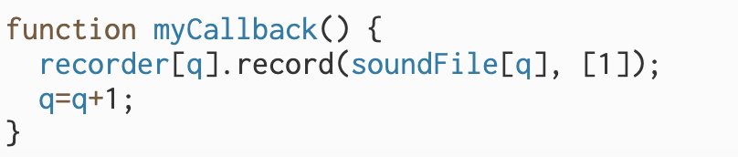

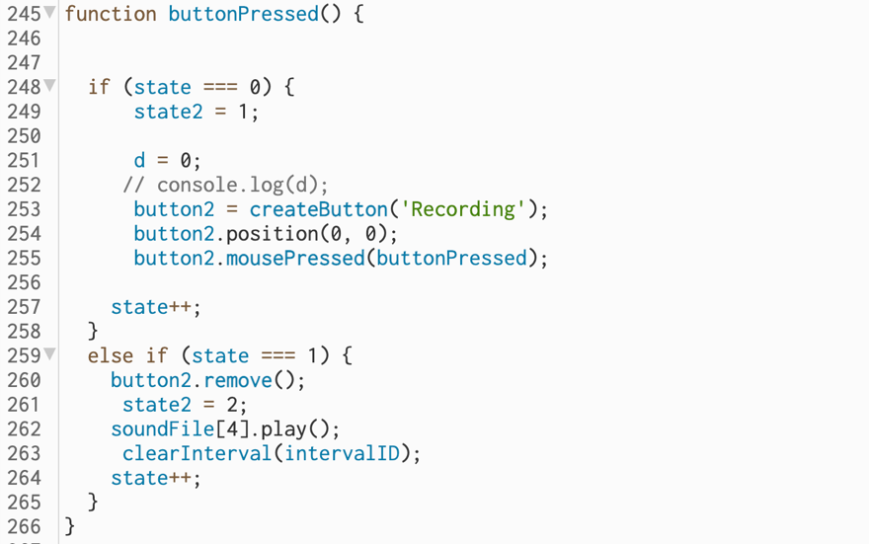To note I during testing I also realised that despite me clicking the second button and disabling record mode through console log messages I realised that ‘myCallback’ was still being called back and ‘soundFile’ array still being recorded to. This was confusing as I believed setInterval should only be continuing to callback as ‘state2 ===1’ (button in record mode) however through researching the ‘setInterval’ function further in the source: <https://developer.mozilla.org/en-US/docs/Web/API/setInterval> and <https://developer.mozilla.org/en-US/docs/Web/API/clearInterval> (Accessed: 16 April 2023). I realised that I had to use the ‘clearInterval()’ function to stop this continual interval call back. Therefore, I implemented this within the ‘buttonPressed()’ function so that when the button is clicked to a second time to cancel record mode the ‘setInterval’ function is cleared. This worked as intended and is included in the (5.5) code linked above.

These solutions fixed code so that recording occurred as intended. I tested plugging first ‘soundFile[1].play();’ and then ‘soundFile[a].play();’ and ‘soundFile[i].play();’ into the collision detection function. It worked great. I have a demo below showing this.

In the demo I click the button to enable record and then count through 1-10 slowly. This is to try to get a vocal number in each of the ‘soundFile’ elements. Me counting is not audible in the demo due to the fact only the computers internal audio is recording. I then spawn in particles which play their respective elements in the ‘soundFile’ array upon collision. To note, at this stage I haven’t re-introduced envelope, delay, and reverb functionality so the demo distorts and may sound unpleasant at points.

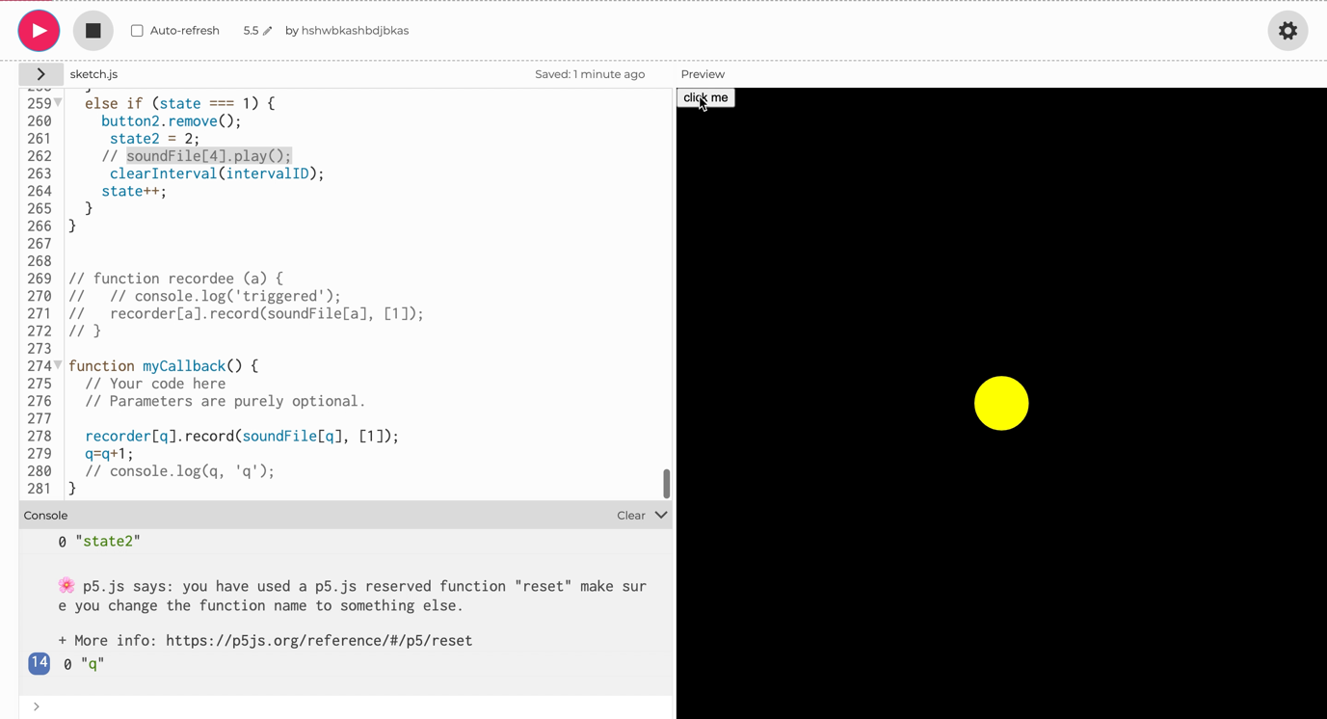

Video file name: Sound for IM Demo.mov

**Week Beginning: 17 April 2023**

The next functionality I want to add to my audio game is the second main interactive element. This is the ability for a user to ‘fire’ particles through the space. I have broken this down into a series of steps.

* First the user should be able to click and hold on specific particles causing them to stop moving (0 velocity).
* Then whilst still holding on to the click the user should be able to move the mouse away from the particle.
* Upon release of the mouse the particle should be ‘fired’ in the opposite direction of the mouse and at a speed proportional to the distance of the mouse from the particle (power).
* There should perhaps be tracer lines indicating where a given particle will fire and potential power upon release of the mouse to aid user control and experience.

At this stage I think I am going to build this using ‘mousePressed’ and ‘mouseReleased’ functions.

First, I need to determine if the click matches up with any particles. I opened a ‘mousePressed()’ function and copied a section of the ‘CollisionSearch’ function into it namely the part with the for loop. However, I edited this removing unnecessary sections (such as creating red circles) and changing all variable names to have an ‘m’ as the first letter rather than an ‘a’. Also, I introduced mouseX and mouseY.

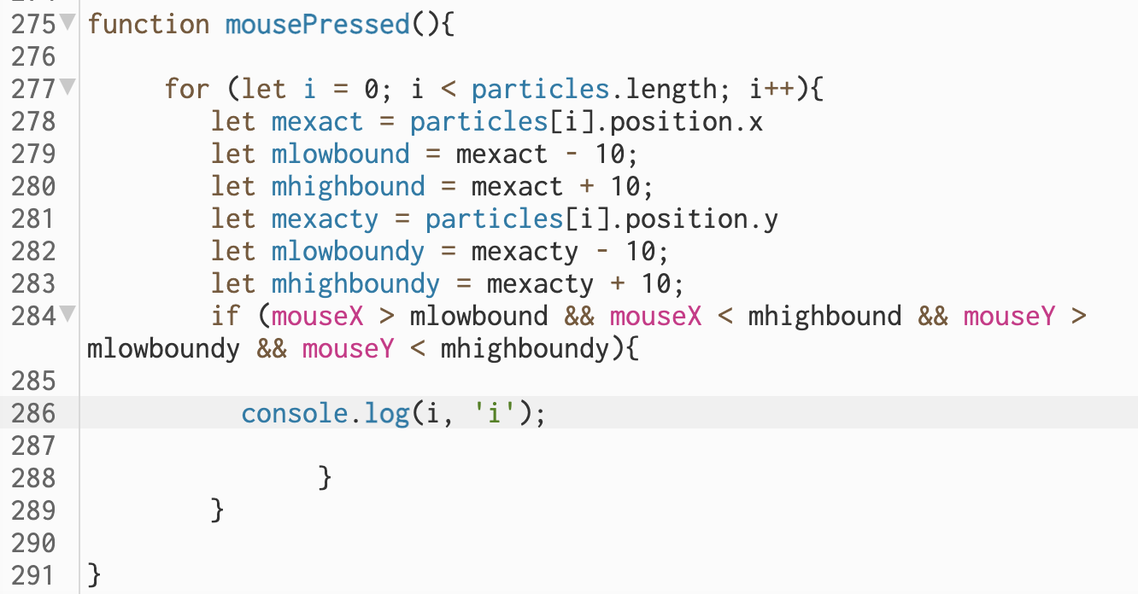

Upon testing I realised it was quite challenging to click on the particles exactly, so I doubled the clickable size by increasing the bounds e.g.

‘ let mlowbound = mexact - 20;’

However, I have a problem where I click on a particle, but it generates another particle. I don’t want every time a user tries to ‘fire’ a particle for another particle to be generated. One idea would be for a switch to allow users to decide between generate and ‘fire’ mode. I think this is probably the most practical because it will allow me to make the boundary around particles in which users can click and release to cause them to be ‘fired’ much larger. This would reduce player frustration between accidently ‘firing’ particles when trying to generate them and vice versa (if I had a large boundary area) or users finding it difficult to click on particles as they move quickly if I had a small boundary area.

I am going to create a slider with two potential values 0 and 1. I will then use this value within if statements within the generate particles and ‘firing’ them functionalities of the code.

I created the slider and a text box with help from:

* <https://p5js.org/reference/#/p5/text>
* <https://p5js.org/reference/#/p5/createSlider>

I then assigned a variable ‘Mode’ to the value of ‘slider’ (‘Mode = slider.value();’) within the draw loop so it’s constantly updating. Just to note, I know I need to go back at some point and fix the ‘particlesAudio’ array and ensure that users can engage recording at will (not just once). I deleted some commented-out code in the ‘mouseClicked()’ function simply to keep the patch tidy, but I will reinstate it as necessary.

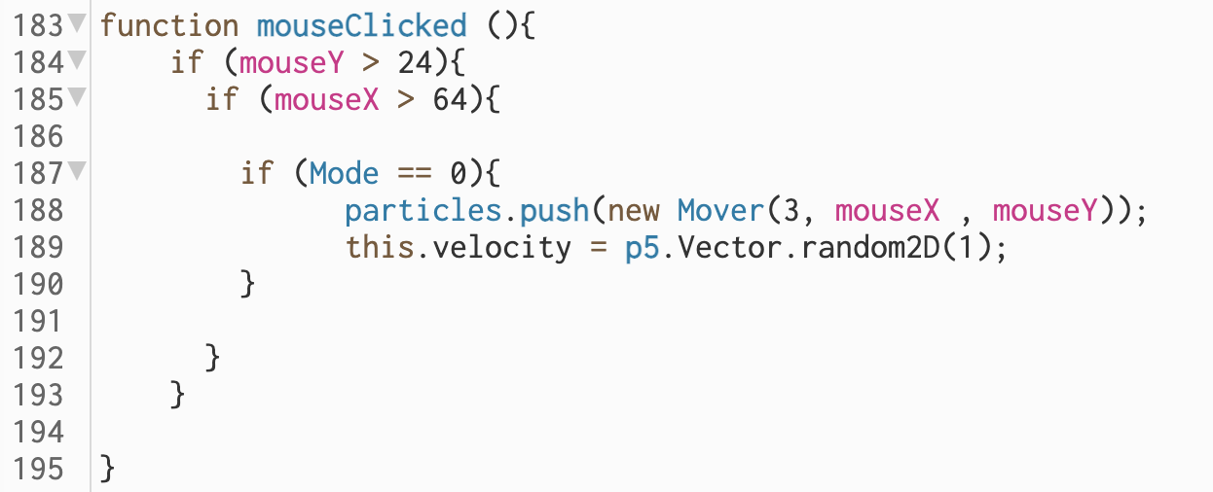

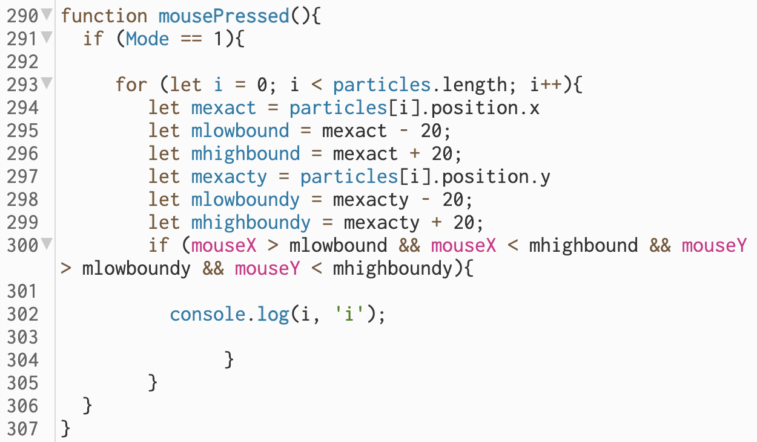

‘Mode = 0’ when the slider is all the way to the left in ‘Generate Mode’ and ‘Mode = 1’ when the slider is all the way to the right in ‘Fire Mode’.

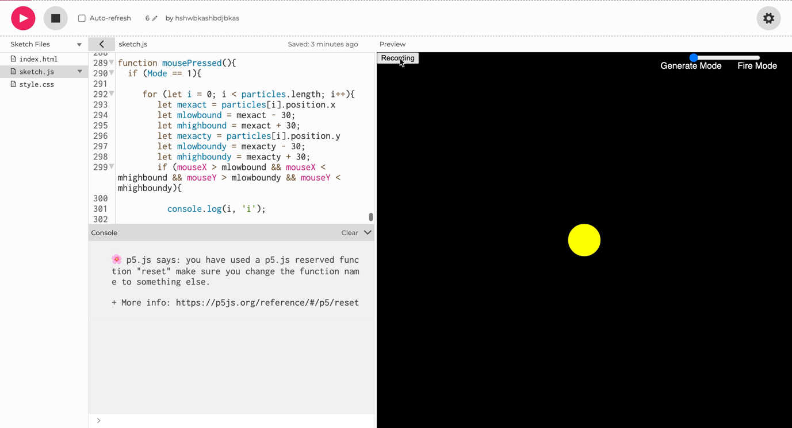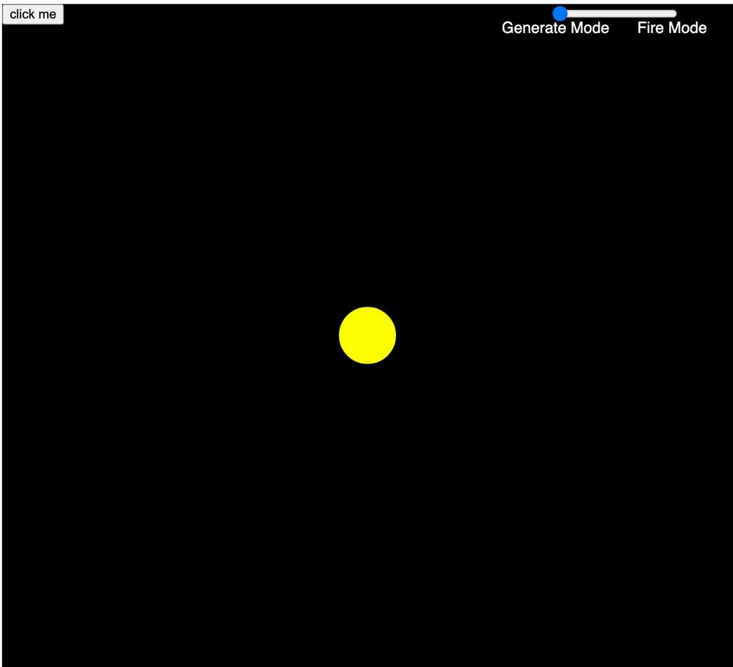

This solution seemed to work well. I also decided to increase the boundaries even more e.g., (+-30). I recorded a video showing how this is working below. There is no sound to this video because it is not of focus.

Video file name: Sound for IM Another Demo.mov

Now I have the index of the particle which the user is clicking on I now need to make its velocity 0 until the mouse is released.

First, I assigned the index of the ‘particle’ the user is clicking on to variable within the ‘mousePressed()’ function.

userClickInput = i;

This is important so that I can access the value within the draw loop in which the forces are applied to the particles. Also, I looked into the ‘mouseReleased’ function due to the fact that I only want the particle to be stationary while the mouse is held down. To aid this I created a new variable and assigned it to 1 within the ‘mousePressed()’ function.

‘releaseb = 1;’

I then created another function ‘mouseReleased’ and within this assigned ‘releaseb’ to equal ‘2’ (shown below). This is important because I can create a set of if statements using these variables to create the logic that resumes normal particle movement as particle is made stationary only while the ‘releaseb = 1’ if the mouse has been released (mouseReleased function is called) ‘releaseb’ doesn’t equal 1 and is no longer stationary.

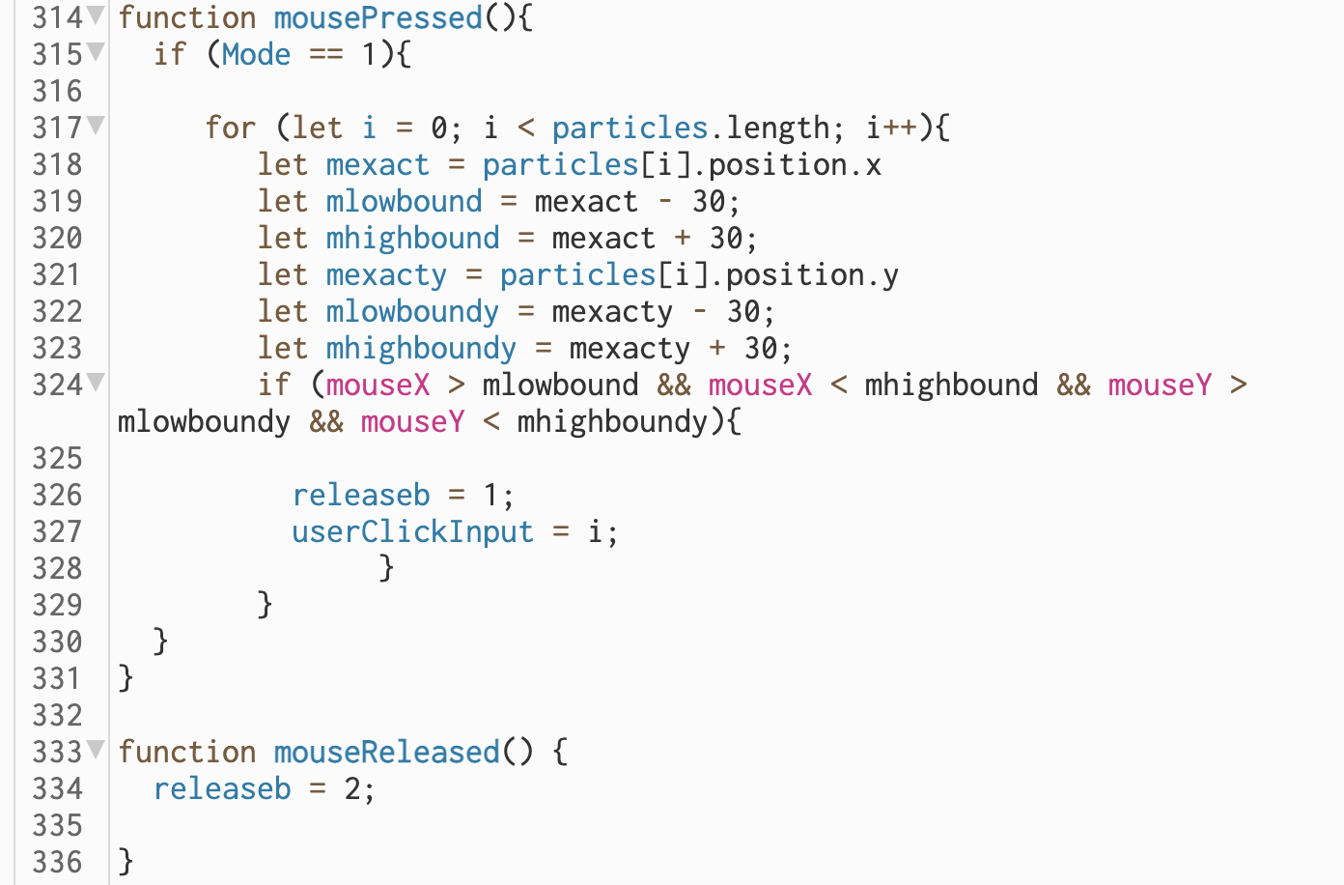

The reason why any given particle is moving is due to the force applied to it within my code. Each particle is acted on by the ‘gravity’ force and to make any particle stationary I simply need to apply an equal and opposite force to its ‘gravity’. I created the ‘Mover.prototype.applyForce2’ function which took aspects from the ‘Mover.prototype.applyForce’ and ‘Mover.prototype.update’ functions to create an automatically updating counter ‘gravity’ force for any particle. Key here is the use of the ‘.sub’ object which subtracted parameters instead of adding them which was used originally for the ‘gravity’ force related functions.

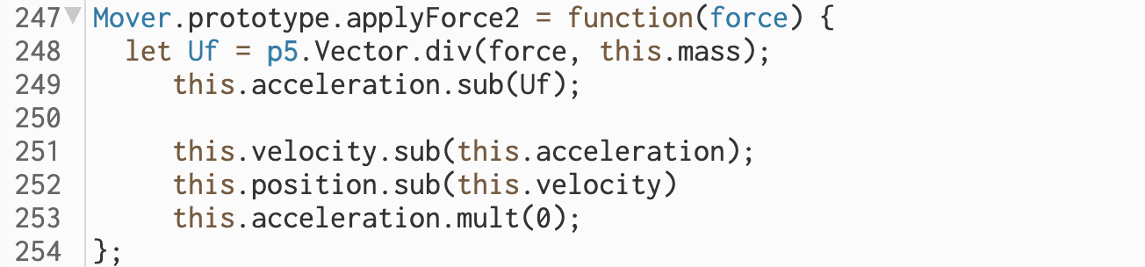

I then implemented this using if statements within the for loop within which the original gravity forces are applied to the ‘particles[]’ array as shown below.

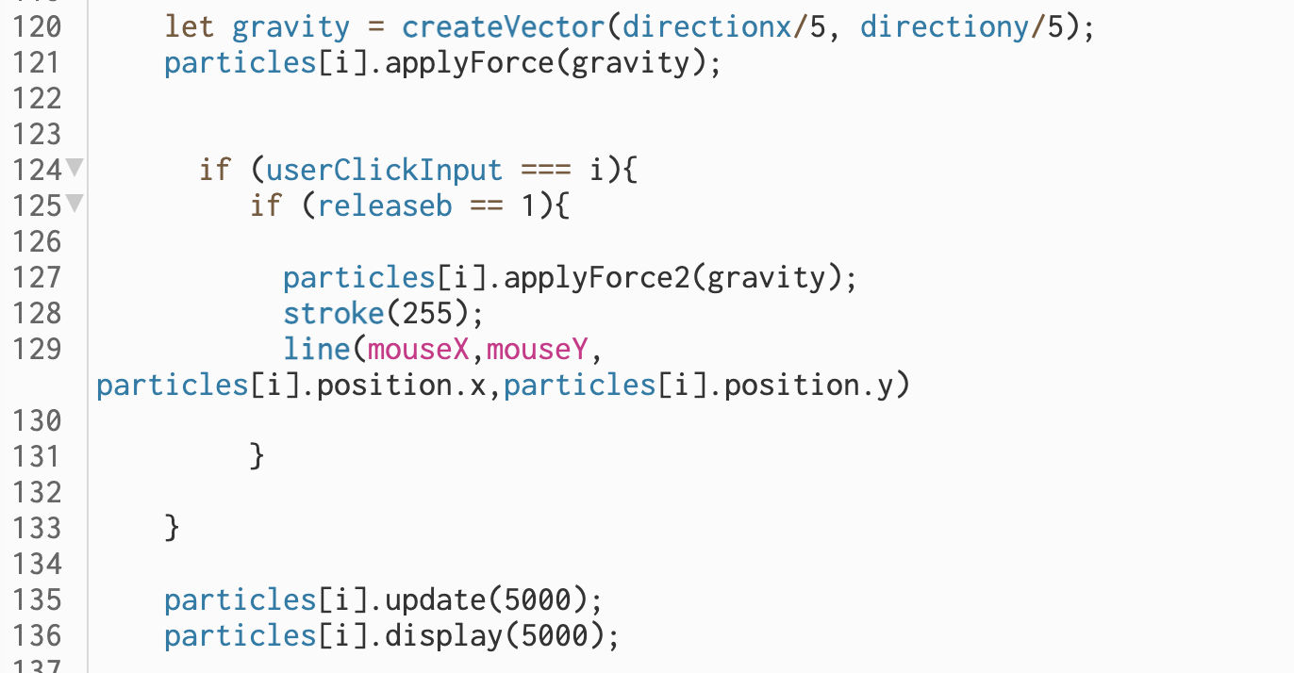

If a particle (element in ‘particles’ array) has been clicked on and the mouse has not been released ‘Mover.prototype.applyForce2’ function with the original ‘gravity’ vector passed as a parameter is applied to that specific particle. This cancels out the force already acting on it and makes it stationary. I have also created a line at this point between the mouse and the particle in anticipation of next step where I will make the particle fire off in a user defined direction when the mouse is released. The line therefore will help for aiming. A video below shows how this is working. Code: https://editor.p5js.org/hshwbkashbdjbkas/sketches/xjvOYAxHz

As you can see when the mouse is released the particles are once again acted on by the ‘gravity’ force.

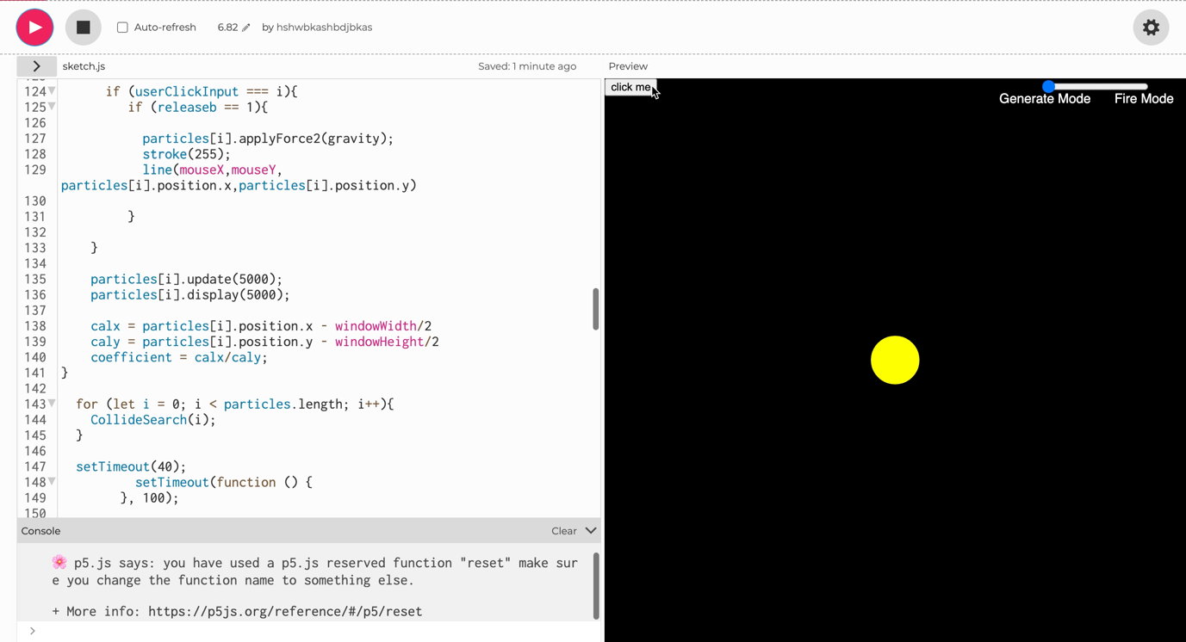

Video file name: Screen Recording 2023-04-19 at 15.35.34.mov

Next, I needed for the particle to be ‘fired’ in a direction controlled by the user after the mouse is released. I want the particle to be fired in the direction opposite to the line currently created.

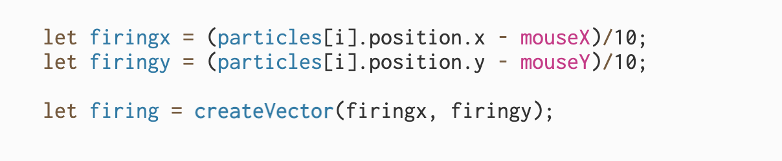

I created a new set of variables ‘firingx’ and ‘firingy’ which essentially took the opposite position of the line I had created between the particle and the mouse previously discussed. I then applied these variables into a vector and using an if statement with a condition relating to the ‘releaseb’ variable. If the ‘releaseb’ variable =2 the ‘firing’ vector is applied as a parameter to the ‘Mover.prototype.applyForce’ function. This means the force is only applied on mouse release as once it is applied ‘releaseb’ is increased by 1 and no longer ‘== 2’. Only when the mouse is released and ‘mouseReleased’ function is called does ‘releaseb == 2’. Also, to note in initialising the ‘firingx’ and ‘firingy’ I used /10 because through quick testing this seemed to create a good level of force on the particles.

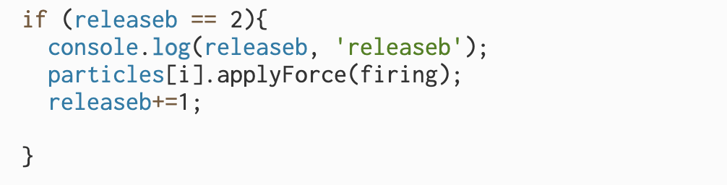

This was great as the user had control over the direction of the particle ‘firing’ however they didn’t yet have control over the power. The image below shows how I implemented this.

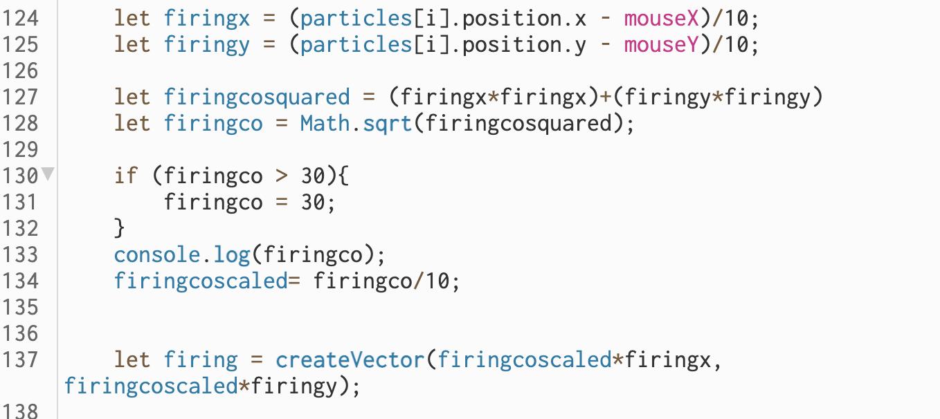

Using Pythagoras’s theorem a2 + b2 = c2 I calculate the magnitude of the combined magnitude of ‘firingx’ and ‘firingy’. This is assigned to ‘firingco’ which can only be calculated after square rooting ‘Math.sqrt(firingcosquared)’ (Source helped me find square root: https://www.programiz.com/javascript/examples/square-root#:~:text=Math%20sqrt()-,To%20find%20the%20square%20root%20of%20a%20number%20in%20JavaScript,sqrt()%20method. (Accessed 19 April 2023). I then put a cap on this using:

if (firingco > 30){

firingco = 30;

}

To define its range ‘0-30’ and then I scaled that range to ‘0-3’. Then I multiplied the x and y parameters of the ‘firing’ vector with this value. This means that dependent on how far away the mouse is from the particle upon release the magnitude of the ‘firing’ force will change. I tested and chose the values for all the ranges e.g., ‘firingcoscaled’ (0-3) so that the user has a good base amount of control over this magnitude, but I may tweak some of these values during testing to ensure the most optimised experience. The code can be seen here: <https://editor.p5js.org/hshwbkashbdjbkas/sketches/dQI5PBWrI>

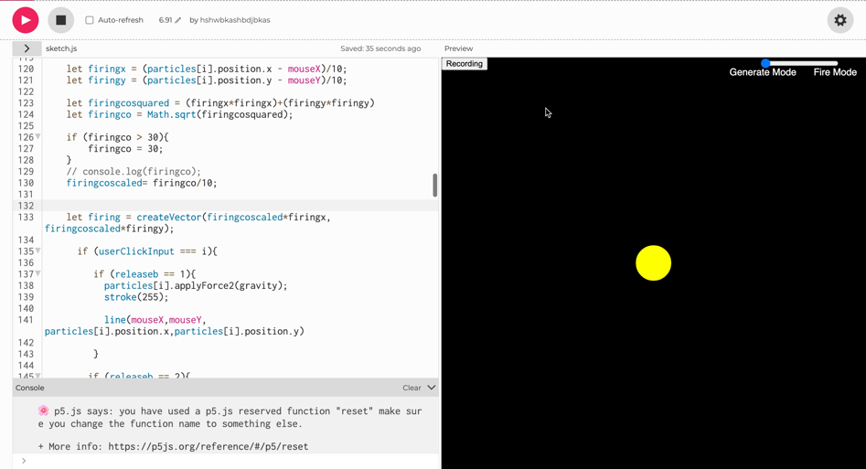

Video file name: Another Interactive Dmeo.mov

As can be seen from the demo there still needs to be work done on the mappings sometimes the particles are ‘fired’ to far sometimes they don’t have enough force. I might experiment with exponential ranges etc. However, I will do this at a later optimisation stage. The most important thing here is that I have created the functionality for user’s to ‘fire’ the particles through the space.

The last big functionality I need to add to my project is the multiplayer element. I am going to add this in but first I want to improve player experience UI elements by creating a clearer aiming system. I added in the line below which was a mirror of the line which I already had in the system. However, I wanted to make the original one dotted so it is clear what direction the particle will be projected towards.

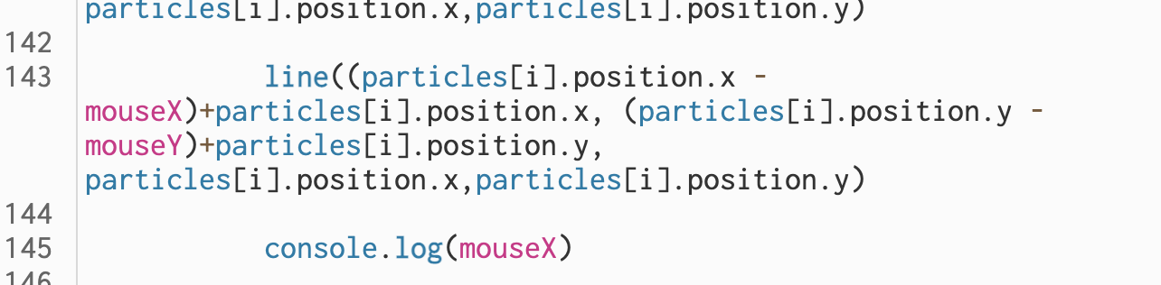

Upon reflection I realised that adding in a dotted line is not really going to give much clarity to the user, instead I want to create an arrowhead pointing in the direction that the particle will be projected towards upon release of the mouse. I also want this to change size in response to the magnitude of an impending ‘shot’.

I made the mirrored line more practical as I know I will need some of the coordinates of this line to place my arrowhead on.

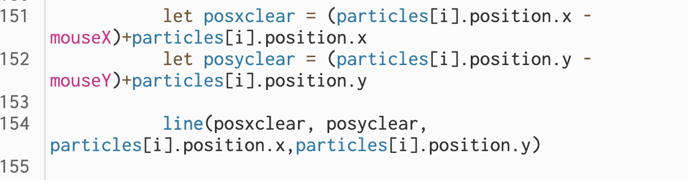

The variables ‘posxclear’ and ‘posyclear’ represent the coordinates of the point on which

the arrowhead will be placed. I then added the code below:



These lines are the arrowhead and move with ‘posxclear’ and ‘posyclear’ however this arrowhead needs to rotate as the mouse moves around the screen right now it doesn’t. Demo shown below:

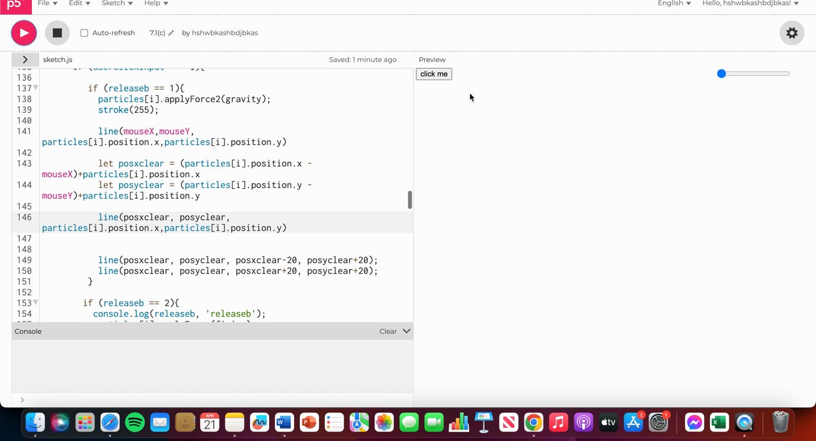

Video file name: Arrow Demo Interactive Media.mov

Code: https://editor.p5js.org/hshwbkashbdjbkas/sketches/UFhEPmEra

I researched into the rotate reference page. (Available at: <https://p5js.org/reference/#/p5/rotate> (Accessed: 20 April 2023)). I knew I had to use ‘push()’ and ‘pop()’ to isolate the rotation as I only wanted the arrowhead lines to be rotated. I experimented with applying different values within the rotate object but found that the arrowhead lines were moved across the screen away from the required axis of rotation ‘posxclear’ and ‘posyclear’.

This source available at: https://developer.mozilla.org/en-US/docs/Web/API/CanvasRenderingContext2D/rotate (Accessed: 20 April 2023), was extremely useful in helping me understand that I had to use the transform object to isolate the axis of rotation.

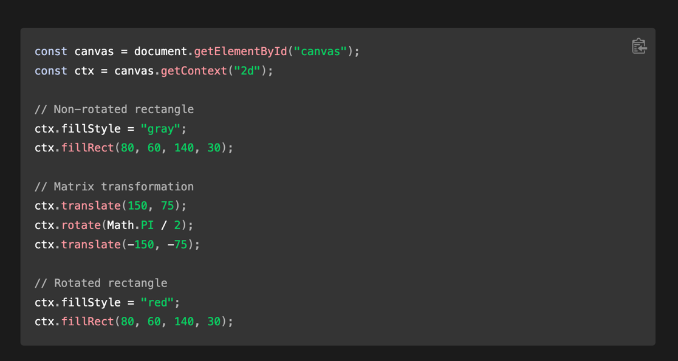

I must translate to the required centre of rotation, apply the rotation than apply the opposite translation.

Code: <https://editor.p5js.org/hshwbkashbdjbkas/sketches/npu9AGI0R>

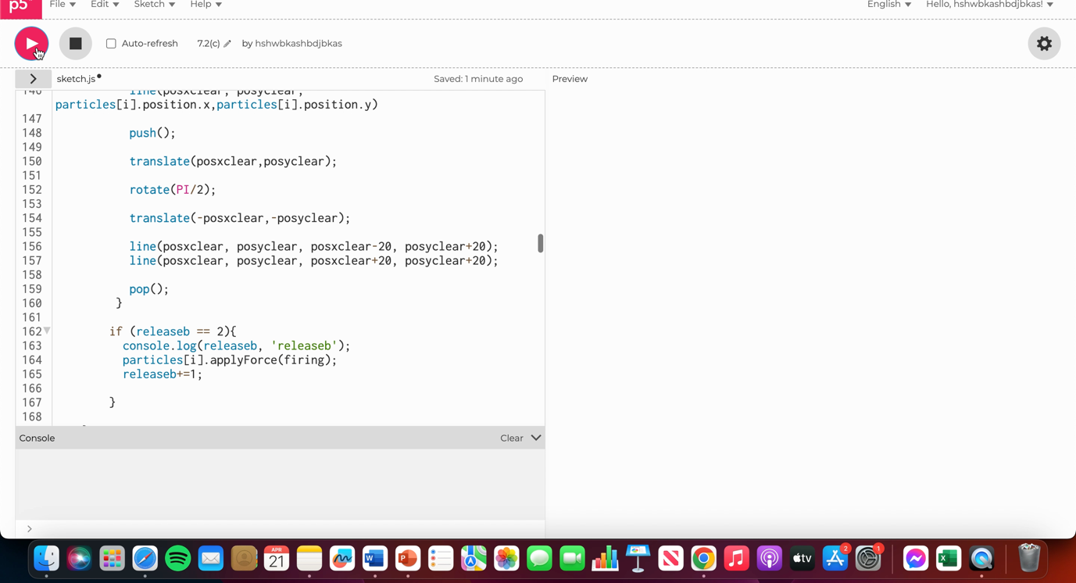Demo:

Video file name: Demo 2 Arrows Interactive.mov

Next, I needed to change the angle of rotation with the movement of the mouse so that the arrowhead is always facing outward from the particle. For this I knew I would need to use some trigonometry. I created the variables ‘xtaner’ and ‘ytaner’ which represented the distance from ‘posxclear’ and ‘posyclear’ to the particle. I will use the values as two sides of a triangle in a trigonometric equation where I need to work out an angle. I did some more research to refresh myself on trigonometry the source: <https://byjus.com/maths/sin-cos-tan-values/> (Accessed: 20 April 2023) was very useful. An image on the webpage shown below helped me work out the equation I will need to use.

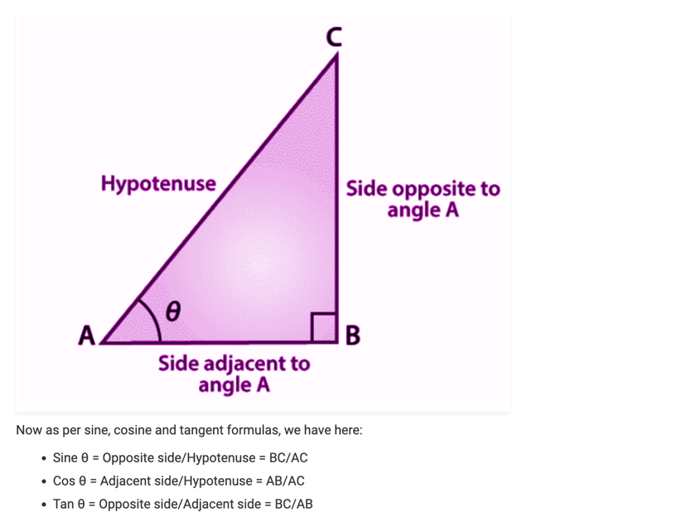

Side opposite to angle A = ‘ytaner’

Side adjacent to angle A = ‘xtaner’

Therefore, Tan θ = ‘ytaner’/’xtaner’

The angle θ is going to be vital in working out the angle of rotation needed. I would then need to take the inverse tan or arctan(‘ytaner’/’xtaner’) to work out angle θ. This resource <https://www.educative.io/answers/what-is-mathatan-in-javascript> (Accessed: 20 April 2023) informed me of the ‘Math.atan()’ function which takes the inverse of a tan function this was absolutely vital. I set assigned the variable ‘rotar’:

**let rotar = Math.atan(ytaner/xtaner);**

The variable ‘rotar’ then stores the angle θ. I realised through passing this value through to the console log that it is in radians rather than degrees and I will need to take this into account when using the variable in the rotate object.

As the mouse rotates around the particle at some points ‘xtaner’ and ‘ytaner’ will be negative. A negative value might cause issues within the objects which I plan to use the value within, also it’s unnecessary and might introduce a lack of clarity in the code. To negate this, I decided to introduce some if statements which act to make all the values positive. This important because I don’t need negative angles.

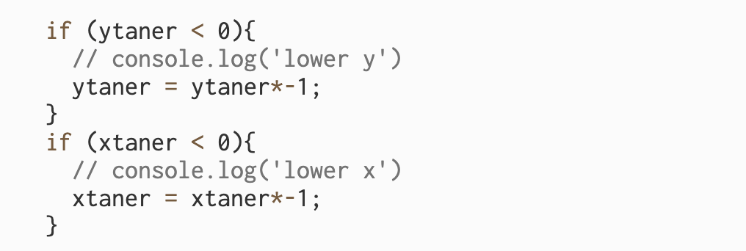

I plugged the ‘rotar’ variable into the rotate object (I didn’t need to calculate a conversion as it is already in radians and that is what the ‘rotate’ object is expecting). However, the code didn’t act as I expected.

Code: <https://editor.p5js.org/hshwbkashbdjbkas/sketches/62NbTL2uJ>

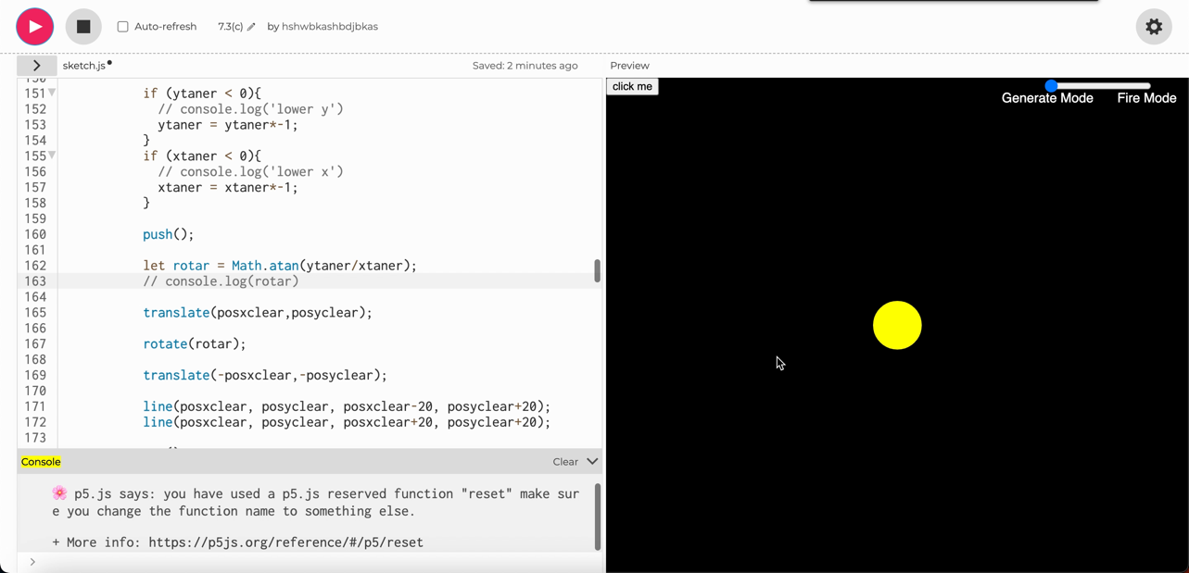

Video file name: Another Demo 7.3c.mov

I quite quickly realised I made an oversight ‘rotar’ = angle θ but this is not necessarily the angle of rotation needed. Due to the way I’ve worked out angle θ depending on the quadrant that ‘posxclear’ and ‘posyclear’ are in around the particle I need to add on either ‘0’, ‘90’, ‘180’ or ‘270’ degrees this is because the angle θ cannot be equal to or larger than 90 degrees. Using the console log I tested which quadrants ‘xtaner’ and ‘ytaner’ are positive and negative and created a new set of if statement assigning values to variable ‘tanercumu’.

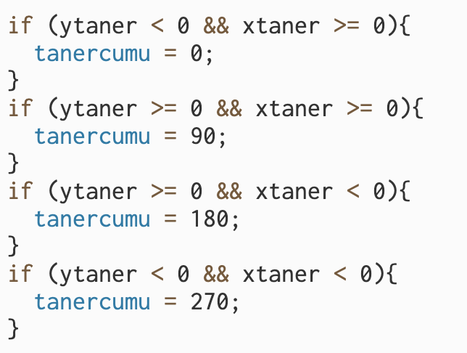

For instance, when aiming in the top right quadrant of the particle ‘ytaner’ is less than 0 and ‘xtaner’ is larger than or equal to 0. This zone occupies 0-90° clockwise from the ‘12 o clock point’. And therefore ‘tanercumu = 0’ nothing will be added to ‘rotar’ within the ‘rotate’ object. Within the rotate object I used:

‘rotate(rotar+(tanercumu*PI/180))’

‘tanercumu’ is converted to radians via ‘*PI/180’.

Code is shown here: <https://editor.p5js.org/hshwbkashbdjbkas/sketches/Y5Ff3tKPE>

Interestingly this works for the top left and bottom right quarters but not for the other two.

A demo is shown below:

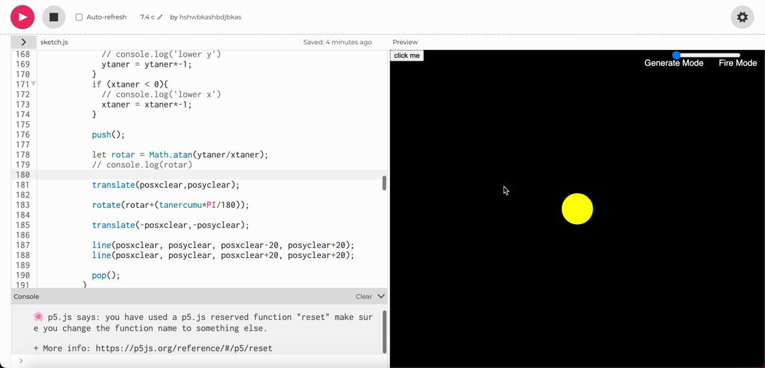

Video file name: Demo IM Arrows 3.mov

Through printing ‘rotar+(tanercumu*PI/180)’ through the console log and further testing I realised that the angle being measured for these not-working quarters and therefore ‘rotar+(tanercumu*PI/180)’ is not right. Taking the image example from <https://byjus.com/maths/sin-cos-tan-values/> (Accessed: 20 April 2023) again for instance. If measuring from the ’12 o clock’ position as 0°, angle θ is not the required angle of rotation but 90° - angle θ is the angle of rotation required.



I fixed this by introducing IF OR statements and adjusting a different parameter for the ‘rotate’ object for angle 0° and 180°.

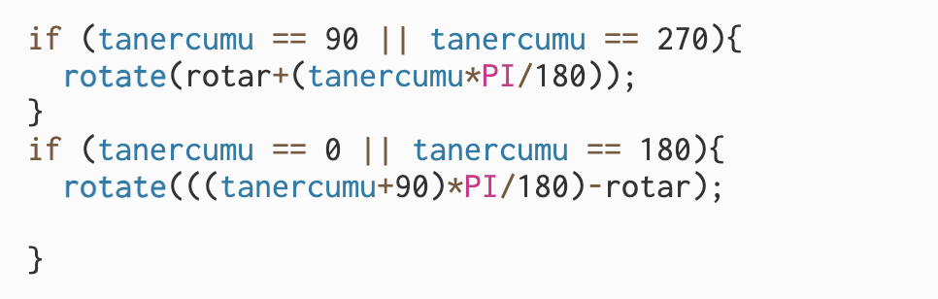

This fixed the issue. Furthermore, I wanted to scale the arrowhead with the magnitude of a potential mouse release projecting the particle. Within the creation of the arrowhead lines, I multiplied the previously constant (20 – indicating the length of the lines) with ‘firingcoscaled’ (the variable linked to the magnitude of a potential mouse release projection with a value 0-3 ). This also worked great. All of these additions can be seen in the code here: <https://editor.p5js.org/hshwbkashbdjbkas/sketches/bsX-Aimfm>

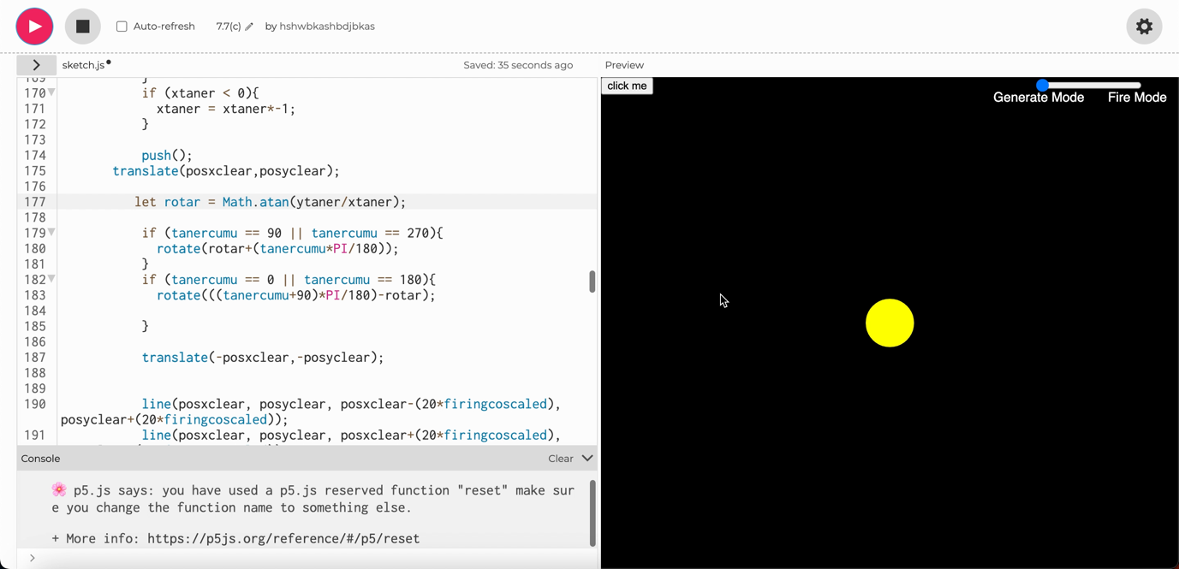Demo video:

Video file name: Demo Final arrow 2.mov

The next and final main functionality I need to implement into my audio game is multiplayer.

Basically right now I need to make sure that the variables are right for implementing multiplayer. I want ‘soundFile’ to not be shared between the two but ‘soundFile’ elements saved to another array. ‘soundFile’ array should be wiped each time recording is initiated (+ a counter on each click showing how many elements in the array not attributed to ‘particles’). Also I need an auto stop after a certain amount of time so … it doesn’t bug out – above the soundFile limit.

Looking at ‘buttonPressed’ function right after the second if else statement ‘state++’ this means that state is being set to 3. It needs to go back to 0 so that I can re-initiate the record mode. I changed ‘state++’ to ‘state=0’

I think if start clicking – q needs to be set to what it started just recording at – I kind of like the idea that one you record it its gone – unless you’ve clicked it in

**Week beginning: 1st May 2023.**

Next, I needed to add in the looping functionality. I am taking code from 8.0 because I had a problem with 8.1 – will go back and add what I need from 8.1. Copied 8.0 into 9 as a starting point.

My idea for looper is for that particle have another variable(array) – if it’s on it always plays. I copied over the slider code to create a new slider. However, I realised that I wanted a toggle button instead. A toggle button makes more sense to me because it’s either on or off. I found this code for a toggle button example: https://editor.p5js.org/turtlefingers00@gmail.com/sketches/0SzmcMEB3 (Accessed: 5 May 2023).

I utilised this code changing some particular styling and positioning the button in the location I wanted. I also change it from a circle to a rectangle. I had to amend my ‘mouseClicked’ function because when the button was clicked a particle was being created. I added in an IF OR statement so that a new particle is created if the mouse is not positioned over the button location:

if (mouseX > btnX+2*radius || mouseX < btnX || mouseY > btnY+radius-5 || (mouseY < btnY)){

Just to note also as I implemented turtlefingers code I incorporated there ‘mousePressed’ function code into my function of the same new.

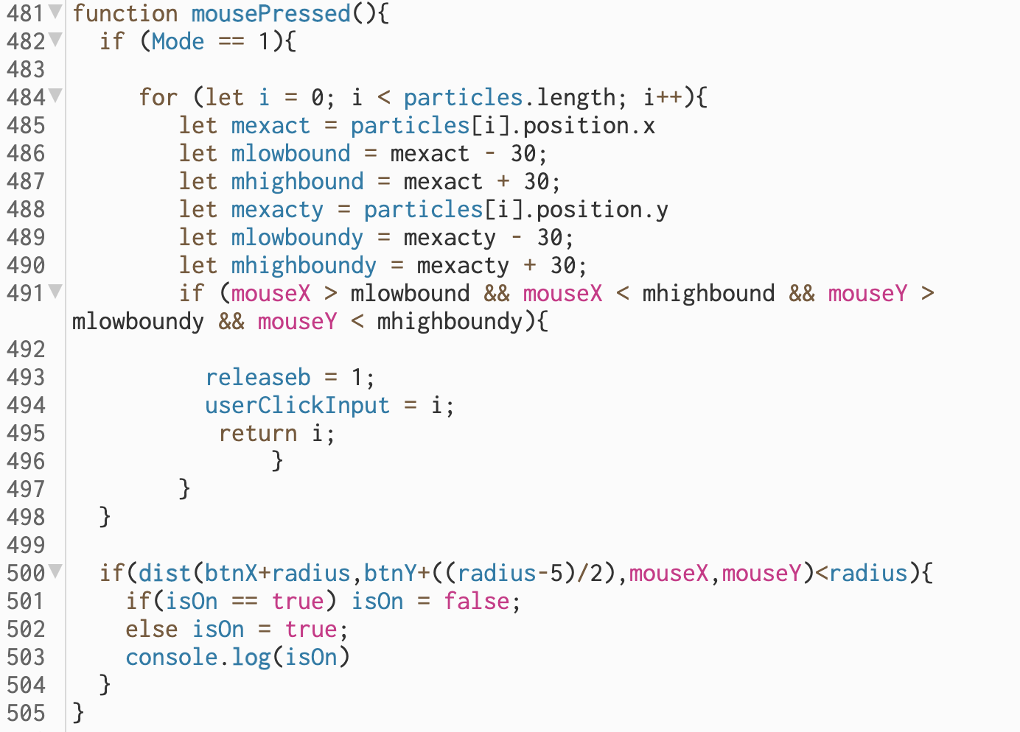

I then initialised a new array in the setup function called ‘Looper’ and set every element in it to ‘0’. In my ‘CollideSearch’ function I wrote out the following code:

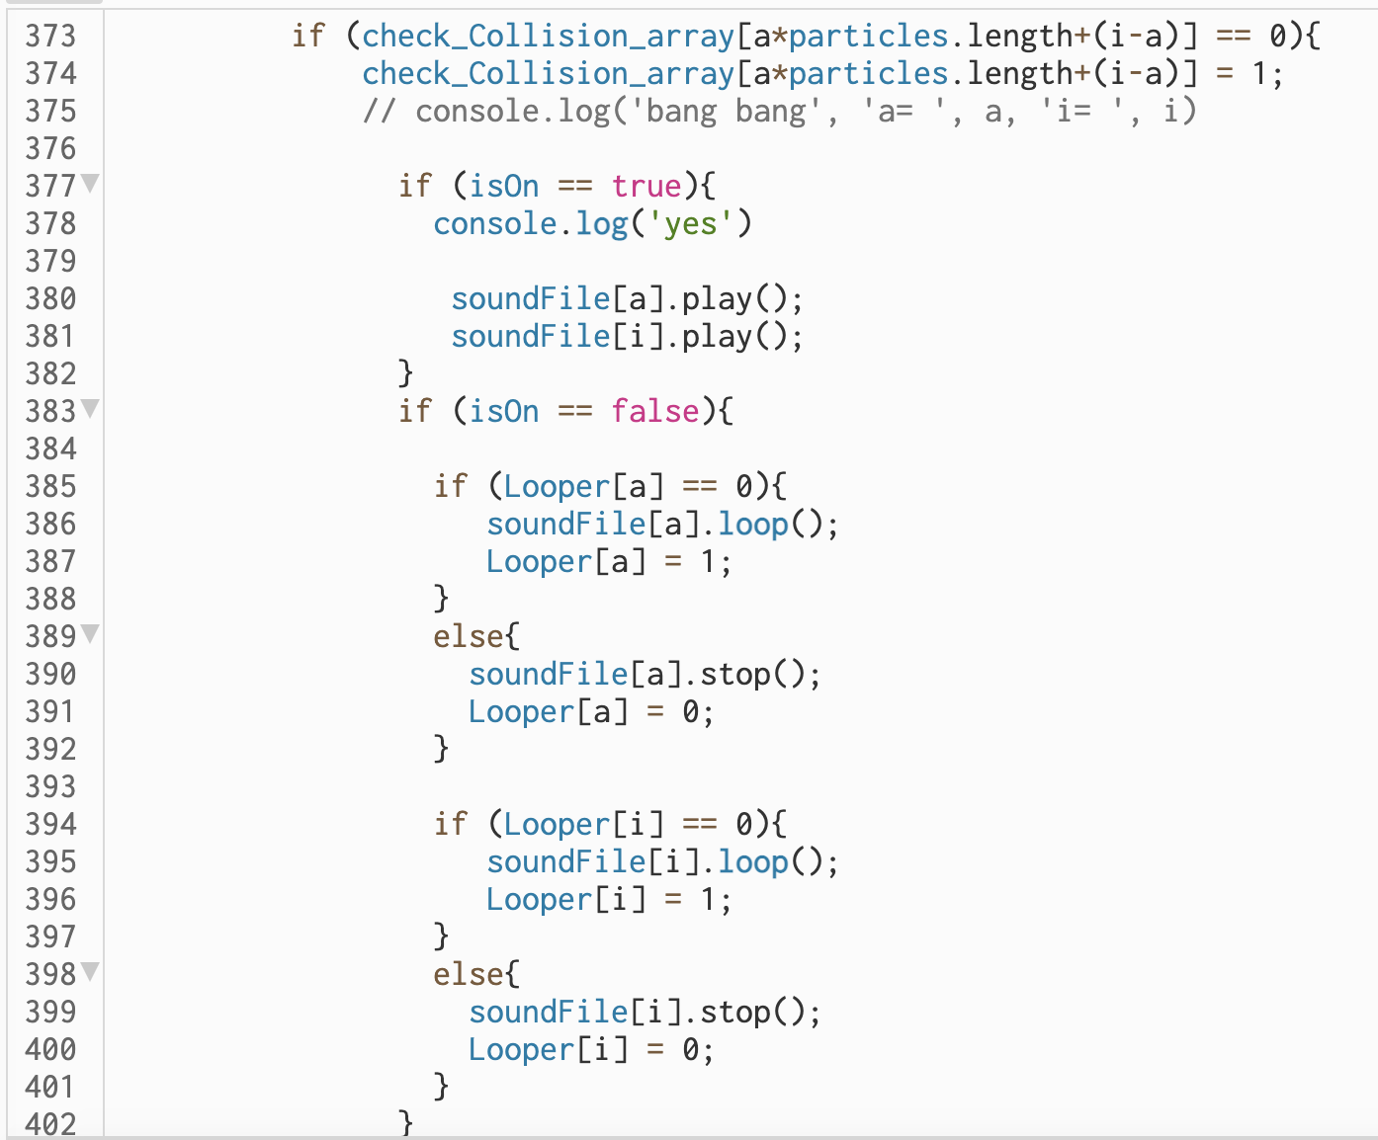

When ‘isOn == true’ and the button indicates ‘Looping = OFF’ the ‘soundFile’’s are triggers as normal. When ‘isOn == false’ and the button indicates ‘Looping = ON’ then for ‘a’ and ‘i’ independently if statements check if e.g., ‘Looper[a] == 0’ if this element in the ‘Looper[a]’ array is ‘0’ which will be initially the case then ‘soundFile[a]’ starts looping and ‘Looper[a]’ is set to ‘1’. When the particle collides again ‘Looper[a] == 1’ so else statement is triggered and the looping will be stopped, also ‘Looper[a]’ set back to ‘0’. This is also the case for the ‘i’ indexes and is important because it allows triggering of looping and then the stopping of the looping when a particle collides again.

I also made some additions to the draw loop. One being that if the button is clicked into the ‘Looping: OFF’ mode and ‘isOn == false’ then a for loop cycles through the ‘soundFile’ array and stops and remaining looping elements.

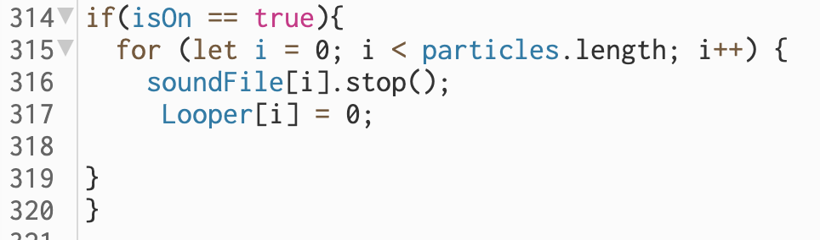

Also, I wanted to show to the player if particles were looping so I at the end of the for loop cycling through the particles index in the draw function I added the below code:

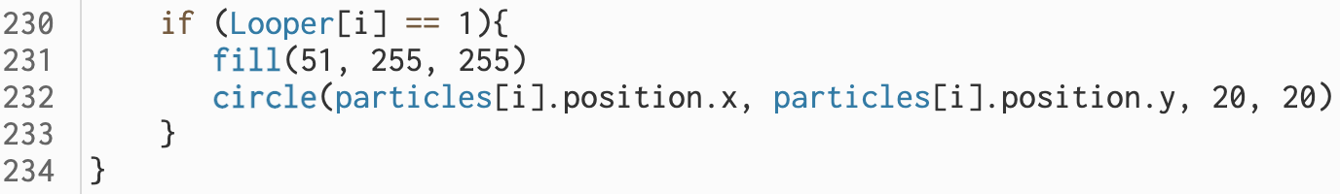

This just meant that if a particle was looping a turquoise circle was overlaid on its position.

The solution has caused me a bit of a problem as during OFF mode it is stopping all the ‘soundFile’s from playing completely. This is obviously caused by the fact that ‘soundFile[i].stop()’ is being called in the draw loop so it is continuously being called. I needed this to occur once. To do this I created another variable ‘isOn2’ initialised as ‘0’ but set to ‘1’ in ‘Looping: OFF’ mode. This assignment occurs in the ‘mousePressed’ function

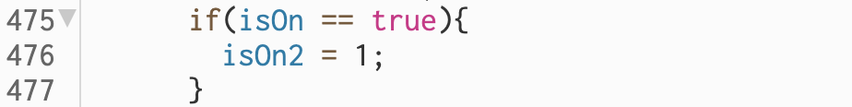

I then amended the code to below (Code line numbers have changed as I removed some commented-out code which hadn’t worked):

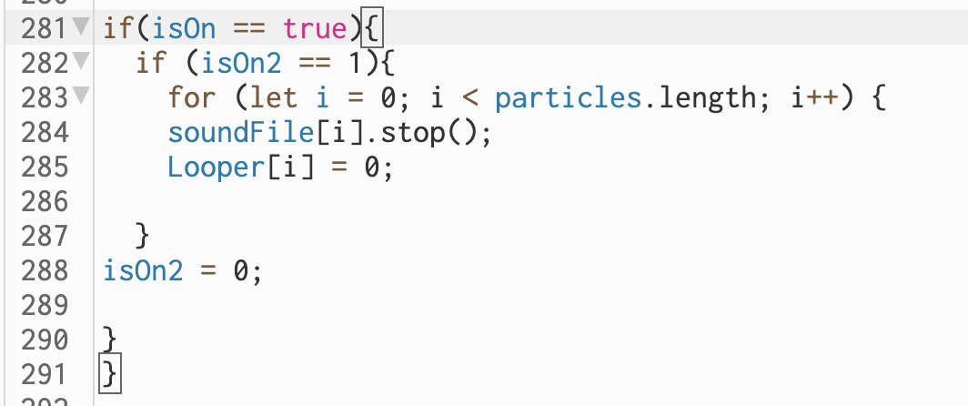

All this code can be seen: <https://editor.p5js.org/hshwbkashbdjbkas/sketches/B1RMd_4o9>

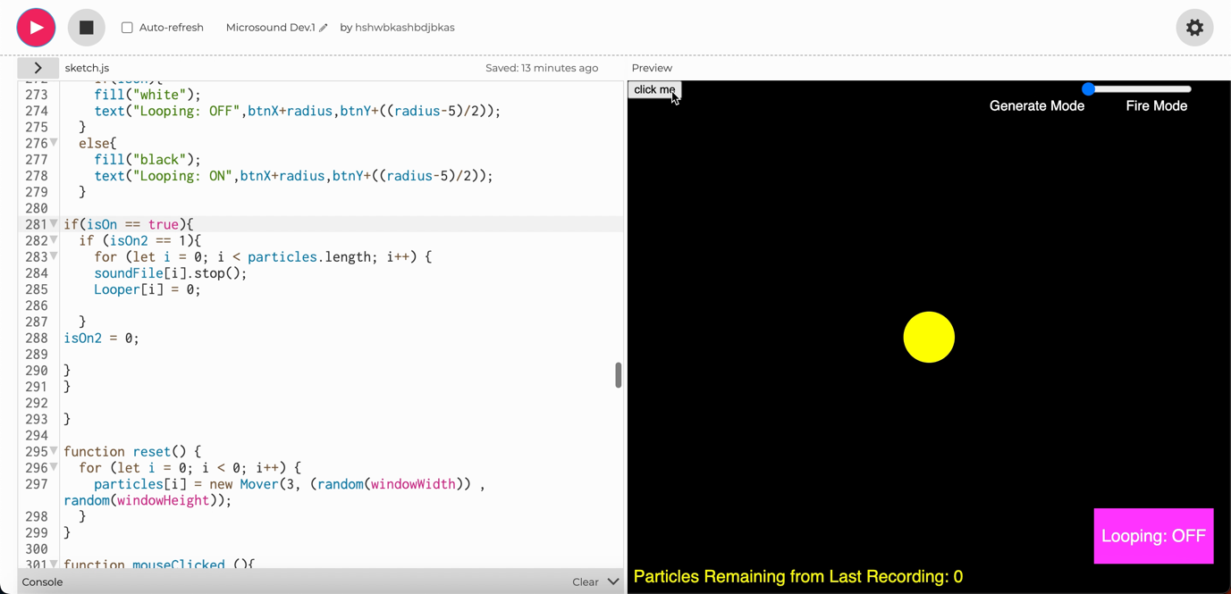However, I had a problem. This can be seen in the demo below. Essentially the code works as expected in the first ‘Looping: OFF’ mode and then also as expected when the button is clicked and ‘Looping: ON’ mode is activated. However, after this when the button is clicked again and ‘Looping: OFF’ mode is re-engaged the sounds continue to loop in a seemingly more uncontrollable way than in ‘Looping: ON’ mode.

Video file name: IM DEMO....mov

I tried a lot of different solutions to fix this. For example, I tried to use ‘.noLoop()’ or soundFile[i].loop = false’ to re-enter single play mode. As described in: <https://stackoverflow.com/questions/32077459/play-sound-only-once> (Accessed: 5 May 2023).

I also looked at using ‘.duration()’ and ‘currentTime()’ to see if I could stop the looping after one iteration however when inspecting ‘currentTime()’ in the console log, I realised that the ‘soundFile’[s] were being rapidly re-triggered. I isolated this problem down to the use of the ‘.loop()’ function. The use of this function seems to be the problem as going back to using ‘.play()’ for the same element of ‘soundFile[]’ afterwards become erroneous.

I decided to fix this by creating an independent but identical array ‘soundFileL’ which I would loop to keep the two functions separately. I understand that this may not be the most efficient solution however in the interest of project time management it works so I’m going to use it.

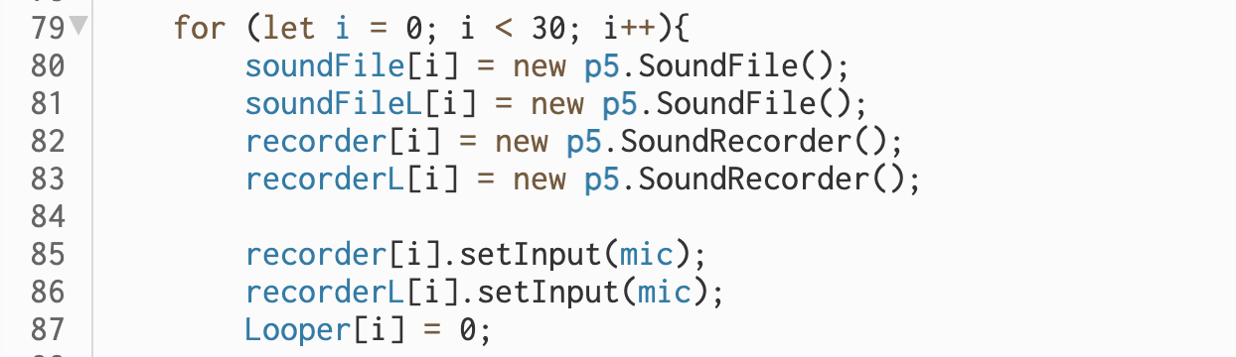

I initialised new ‘soundFileL’ and ‘recorderL’ arrays in ‘setup’ and set the mic as input. I then amended the ‘myCallback’ function which records to ‘soundFile’ and now ‘soundFileL’ arrays.

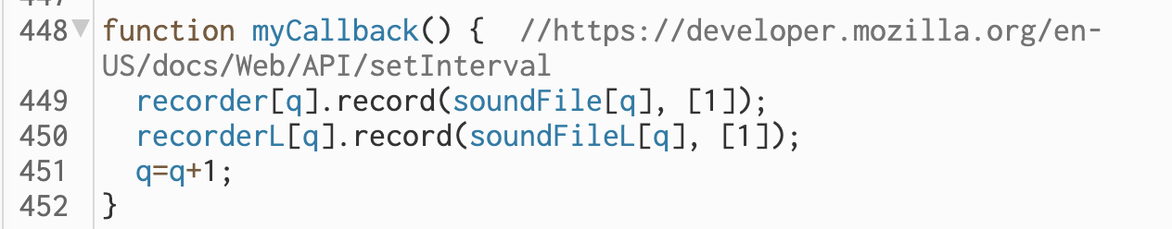

Then you can see below the addition to the ‘CollideSearch’ function. ‘soundFileL’ is used when I need to loop and ‘soundFile’ when I need to a single playthrough.

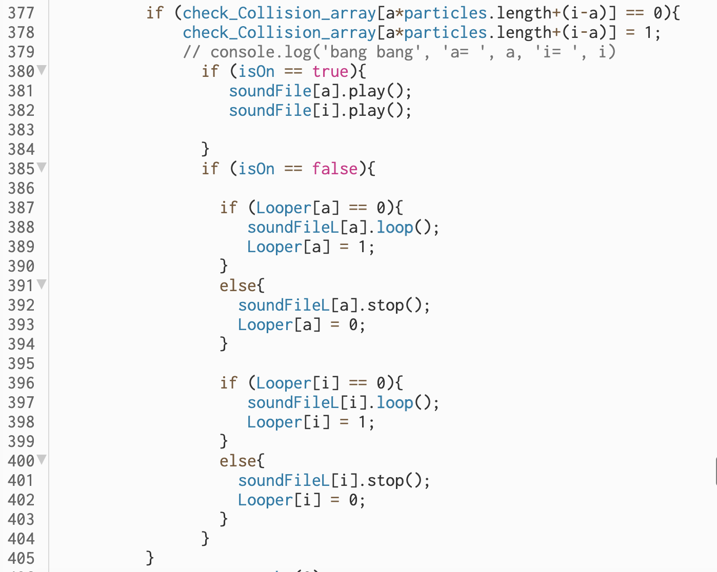

This code can be seen here: <https://editor.p5js.org/hshwbkashbdjbkas/sketches/r4yiO1aOn>

It worked great and as intended.

The next thing I wanted to add was a Title Page to introduce explain the game. This is important to make the game user friendly. I succeeded in doing this quite easily. I created a variable ‘starterscene’ which is initialised as ‘0’. In the draw function, I then created an if else statement. I moved all the code previously in the function into the else statement along with code previously in setup creating the ‘Click me’ button and ‘Firing Mode’ slider. This is so they didn’t show up in my title page. If ‘starterscene = 0’ then title page then if mouse pressed ‘starterscene = 1’, else statement triggered.

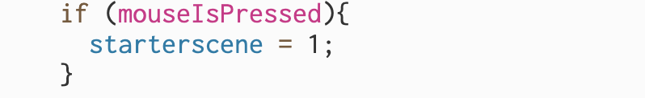

In the if statement I wrote a lot of text with different colours and styling. Nothing brought up a challenge. I used gradually changing ‘rgb’ fill values to create tonal effect.

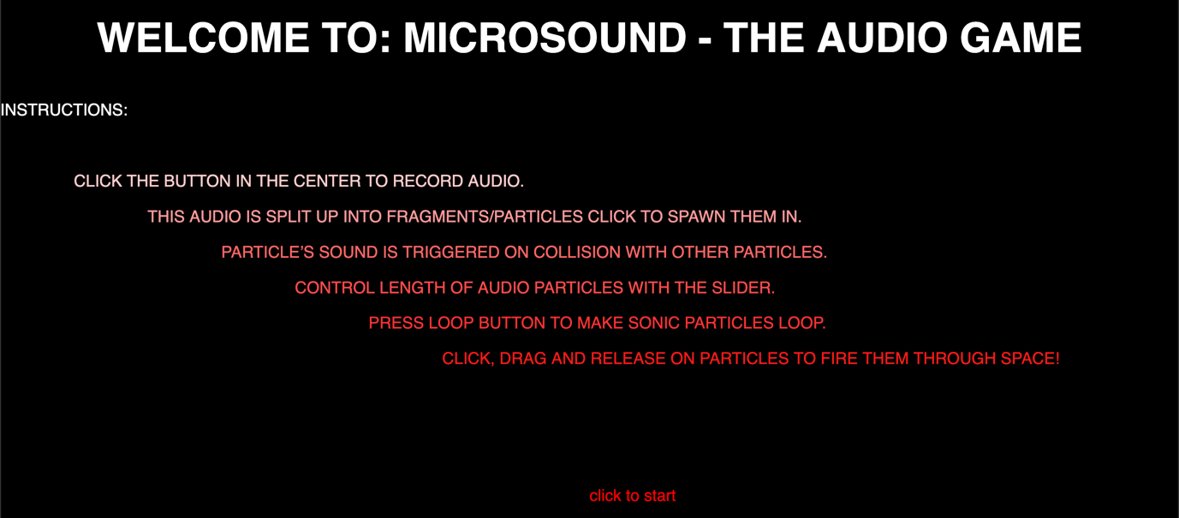

This code can be seen here: <https://editor.p5js.org/hshwbkashbdjbkas/sketches/l3HAf9I5M>

Next, I decided I wanted to move the record button into the centre. I would then try to allow the functionality to change the time of particle length.

I did this pretty easily, but I realised that because I had moved ‘createbutton’ into the draw function when I also moved the ‘Recording’ button into the centre it was overlayed with the ‘click me’ button. This is because the button was now being constantly drawn in the ‘draw’ loop rather than once initially in the ‘setup’. To fix this I created a control variable ‘buttoncontrol’ which is initialised to ‘0’ but increased by ‘1’ in the ‘buttonPressed()’ function. This means that after the button is pressed it is not continually refreshed so it sits in the background to the ‘Recording’ button as required.

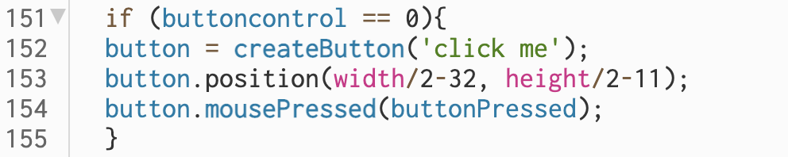

I also moved the ‘dead’ area where mouse clicks wouldn’t generate particles. I’ve done this a few times through the project and simply amended the IF OR LOOPS in the ‘mouseClicked ()’ function to reflect this.

I introduced a second slider which I wanted to use to introduce to functionality for users to be able to change the length of the sound particles/grains being recorded e.g., from 0.01 – 0.1 seconds. However, upon moving the sliders I realised they were not displaying properly. I decided to move them back into the ‘setup’ function and realised I could use the ‘hide()’ ‘show()’ objects. https://p5js.org/reference/#/p5.Element/hide (Accessed: 6 May 2023). I then used ‘.hide()’ in the Title page ‘starterscene == 0’ and then ‘.show()’ in the main game ‘starterscene == 1’

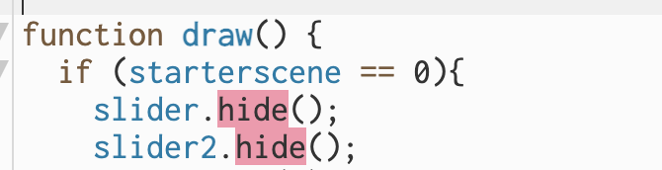

To note my ‘slider2’ parameteres were as follows:

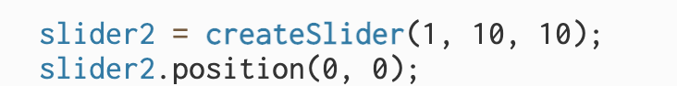

This is what I’m going to use for the variable grain length. In the game section of ‘draw’ I added this code:



Essentially ‘ParticleTimeValScal’ is the scaled value of the slider (right now between 0.1 – 1 however this will change). I will use this variable as a parameter in other sections of my code. For instance:

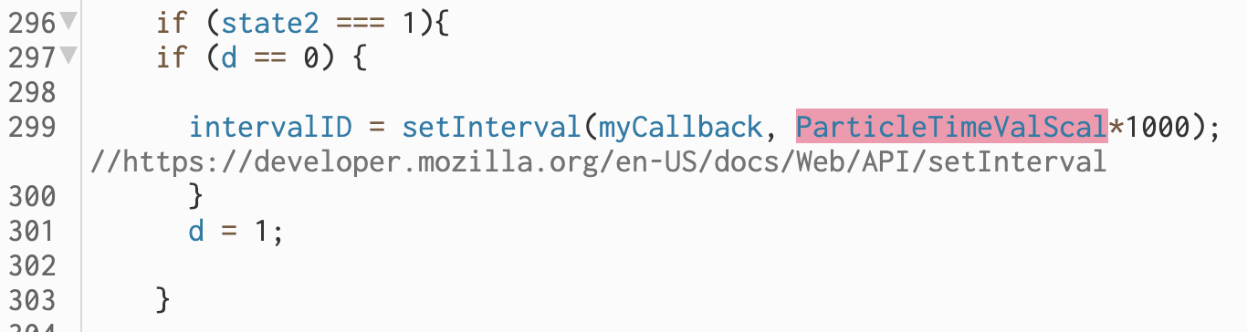

‘ParticleTimeValScal’ has been multiplied by 1000 here because ‘setInterval’ takes this parameter in milliseconds and ‘ParticleTimeValScal’ is in seconds. Also, as a parameter upon recording into ‘soundFile’s arrays:

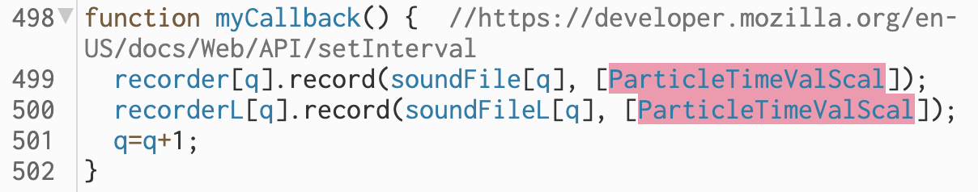

Upon testing I realised at this point sound was getting quite distorted so I acted to re-introduce the envelope, reverb, delay which I had previously implemented but commented out for the sake of simplicity.

Now this is slightly complex because I need to make the envelope variable depending on the size of the duration of the soundfile. I created an array ‘rampvar’ which I used to store the ‘ParticleTimeValScal’ values for each particle in respective indexes in the array in the ‘myCallback’ function. I then used this value in ‘CollideSearch’ to create envelopes sized correctly for the audio files being played by using ‘rampvar’ e.g.



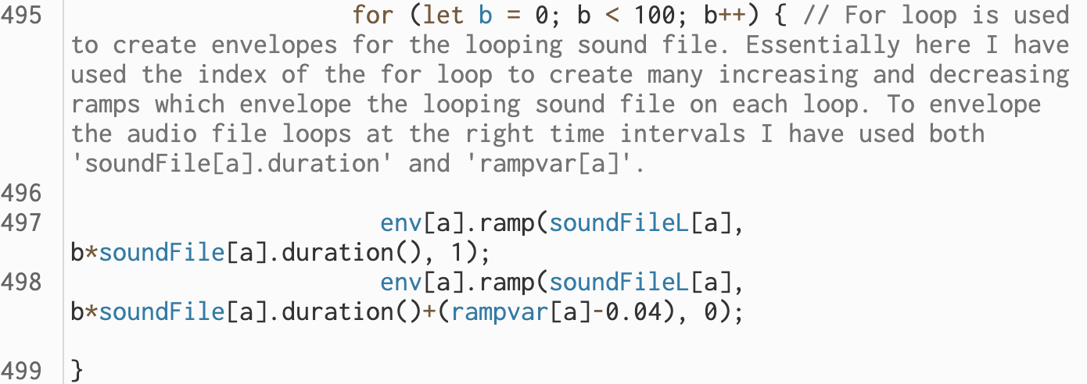

In this section of project development, I also commented up all of the code changed the

name of the function ‘myCallback’ to ‘Recording’ for the sake of clarity.

Upon some final testing I was noticing unwanted behaviour from the particles. I realised that because there were some audio files not being ‘spawned in’ it was causing the indexes of the sound file arrays and particles to not match up. The solution is shown below. I essentially subtracted any unspawned particles from ‘q’ this caused them to be overwritten and therefore the indexes matched up as required.

